Articles and Questions
Each free article of The Canadian Reader includes:
1) a PDF file
and
2) a Word file
These files contain only the article and questions. They do not contain Answer Keys.
This Word file allows students to complete assignments using a computer either at school or at home. Teachers can assign all or parts of the file by email attachment or a school website. The Word file also allows teachers to:
• easily modify and format content including changing fonts and text sizes
• create a PDF document and use Adobe Reader's 'Read Out Loud Mode'
• save paper and copying costs and help protect the environment
• promote and encourage students’ computer skills

What Else Can You Do With The Word File?
#1) You can easily upload the file to Google Docs and share it with students or other teachers. See how here:
https://support.google.com/drive/answer/2424368?hl=en
#2) Translate the uploaded document into another language. (see Tools>Translate document). Google Docs will create a new copy of the original file but you will need to edit the document to suit your requirements. Google Docs can translate into over 100 languages including Spanish, Mandarin, German, etc. See how here:
https://support.google.com/docs/answer/187189?hl=en&co=GENIE.Platform=Desktop

Pedaling Accessibility
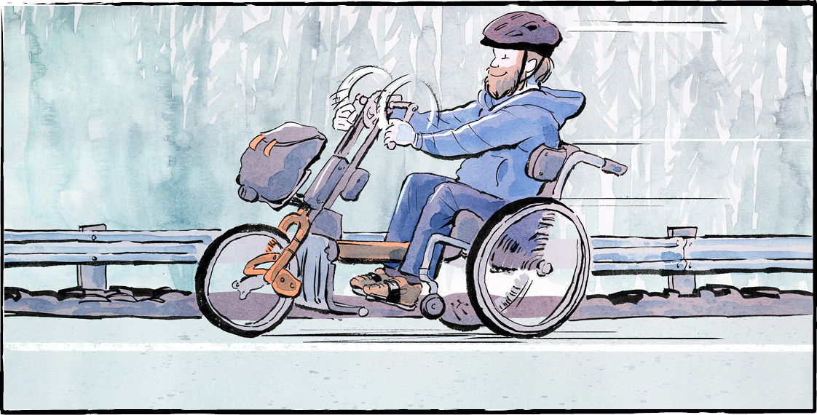

Years ago, Terry Fox set out to cross Canada on his Marathon of Hope. He wanted to raise money and awareness for cancer.
In the 1980s, Rick Hansen crossed Canada in a wheelchair. His Man in Motion World Tour raised millions of dollars for spinal cord research.
Today, Kevin Mills is on a similar journey. Mr. Mills plans to be the first quadriplegic to cross Canada.
He is not running or using a wheelchair. He is biking. He pedals his bike with his arms and shoulders. Those are the only body parts he has full control over.
The bike has a power-assist system, like ebikes. That helps, especially when going uphill! Most of the work comes from Mr. Mills, though.
A life-changing moment
Kevin Mills grew up in Guelph, Ontario. He was athletic. He enjoyed biking, scuba diving, rock climbing, and track.
As an adult on vacation in Cuba, he went swimming in the ocean. A wave pounded him to the ocean floor. The accident injured his spine.
Mr. Mills was paralyzed below the neck. He learned to steer a motorized wheelchair using tiny head movements. Experts told him this was the best he could hope for.
He refused to accept that. “I just wanted to be as active as possible,” he says.
Through therapy, Mr. Mills regained shoulder movement and some control of his arms. This changed his life. Eventually, Mr. Mills and his trainer, Nikki Davenport, began biking together.
Crossing Canada
Ms. Davenport suggested biking across Canada. “It’s something I always wanted to do,” Mr. Mills says. He just didn’t think it was possible.
On May 24, Mr. Mills dipped his tires in the ocean in St. John’s, Newfoundland. That was the start of his journey. It was also his 43rd birthday. “I want to dip my tires in both oceans,” Mr. Mills says.
Mr. Mills and Ms. Davenport ride their bikes for five to six hours a day. Their route to Victoria, British Columbia, will take four months or more.
They often follow the Trans Canada Trail. The trail has been improved in recent years. It is becoming more accessible.
Challenges
Still, the pair has faced challenges. Ruts and washouts make biking hard. Once, in training, Mr. Mills had an accident. He landed in a ditch with his head under water. That was frightening.
In Quebec, one of Mr. Mills’ special bikes was stolen! He switches between two bikes. One is a backup in case something breaks down.
Mostly, people have been kind. Some have helped with donations. Some have even done their laundry. A private donor replaced the stolen bicycle.
Facing fears
Mr. Mills has two big fears around the trip. The first is the Rockies. Climbing mountains with his bike will be difficult. He is also worried about the descent.
His second fear is public speaking. He forces himself past it. He does it to raise awareness about spinal cord injuries.
"I want people with disabilities to see me out there biking and maybe get inspired to do something," Mr. Mills said. He hopes to start conversations about accessibility.

What questions would you like to ask Kevin Mills?

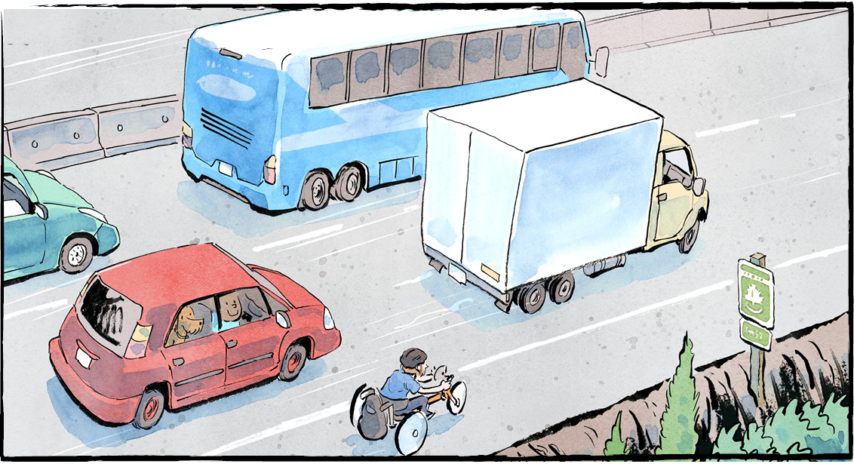
Comprehension Check

Answer the questions below in complete sentences:

1. How is Mr. Mills crossing Canada?

2. What activities did Mr. Mills enjoy when he was growing up?

3. How was Mr. Mills' spine injured?

4. Where did Mr. Mills start his journey?

5. What are Mr. Mills' two big fears concerning the trip?

Language Focus

Unscramble the words below, then write a definition for each one using your own words.

1. ONAEC:

2. OREYJUN:

3. ACESIBCSLE:

4. YPARETH:

5. LCEEHWRAIH:

6. HEASLNGLEC:

7. BCCLYIE:

Comprehension Check - Trans Canada Trail

Mark the statements T (True) or F (False). If a statement is false, write the word or words that make it true on the line below.

______ 1. The Trans Canada Trail is a network of local trails that stretches the length of North America.

______ 2. The federal government began building the Trail in 2000.

______ 3. The Trail was completed in 2017.

______ 4. The Trail is over 24,000 kilometres long.

______ 5. Much of the Trail had to be built from scratch.

______ 6. More than half of Canadians live within 30 minutes of the Trail.

______ 7. The Trail can only be used by walkers and hikers.

______ 8. The Trail is the longest recreational trail in the world.

