Articles and Questions
Each free article of The Canadian Reader includes:
1) a PDF file
and
2) a Word file
These files contain only the article and questions. They do not contain Answer Keys.
This Word file allows students to complete assignments using a computer either at school or at home. Teachers can assign all or parts of the file by email attachment or a school website. The Word file also allows teachers to:
• easily modify and format content including changing fonts and text sizes
• create a PDF document and use Adobe Reader's 'Read Out Loud Mode'
• save paper and copying costs and help protect the environment
• promote and encourage students’ computer skills

What Else Can You Do With The Word File?
#1) You can easily upload the file to Google Docs and share it with students or other teachers. See how here:
https://support.google.com/drive/answer/2424368?hl=en
#2) Translate the uploaded document into another language. (see Tools>Translate document). Google Docs will create a new copy of the original file but you will need to edit the document to suit your requirements. Google Docs can translate into over 100 languages including Spanish, Mandarin, German, etc. See how here:
https://support.google.com/docs/answer/187189?hl=en&co=GENIE.Platform=Desktop

They're Here – Wild Pigs!
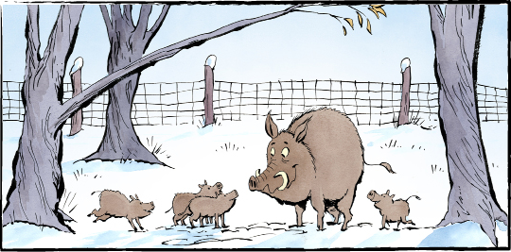
It seemed like a good idea 60 years ago. Bring over boars from Europe (a boar is a wild pig). Start raising them on farms here. People will find the meat very tasty. But be careful — don’t let those wild pigs escape.
Oops
About 30 years ago, some of those imported pigs did escape. They bred with domestic pigs. And now they are spreading rapidly across North America. The hot spot is the Prairies — Manitoba, Saskatchewan, and Alberta.
Why are wild pigs a problem? They are really, really invasive. Incredibly destructive. They’ve been called “an ecological train wreck.”
They eat everything from roots to bird eggs to small mammals. They rip through the ground, destroying crops. They turn over plants to eat roots and get at bugs.
They wallow around in wetlands. “They contaminate the water,” says one ecologist.
“They can transmit disease to humans, pets, livestock, and wildlife.”
“They just do tremendous destruction."
About wild pigs
Wild pigs aren’t cute and cuddly. They are big. They can weigh well over 150 kilograms (similar to a black bear). They have razor-sharp tusks and a long snout. They can be aggressive and dangerous. They move fast.
“And they’re incredibly smart,” says one expert.
They also reproduce rapidly. Sows give birth to two or three litters each year. Each litter has about six piglets. Young pigs start reproducing at just four to eight months old.
“A small problem can turn into a massive out-of-control problem very quickly.”
How to get rid of them
Alberta has set up a tip line called “Squeal on Pigs.” It encourages people to report wild pig sightings.
But once the pigs become established, it’s almost impossible to get rid of them.
The animals are hard to track. They run away at any sign of danger. They hide in thick cover. They make underground burrows or nest in cattails. In winter, they tunnel into snowbanks and build ‘pigloos'.
They’re very suspicious. “They become real wary of humans,” says one scientist.
Hunting doesn’t work. The animals spook and scatter when they hear guns.
“The remaining wild boars will learn to evade future hunting efforts. They will
become more elusive. They’ll avoid humans. They’ll go nocturnal and they’ll disperse.”
Trapping them isn’t easy. Trappers use bait to lure pigs into a corral. They watch them on remotely-operated cameras. Then they drop the gate.
“It’s important… not to have any on the wrong side of the gate,” says one trapper. “Any that escape will become more trap-wise.”
Their growth is exploding. There have been close to 62,000 reports of wild pigs across Canada. More than 75 percent of the sightings have been in the last five years. Now they're spreading into the United States.
“Wild pigs are the worst invasive wild animal on the planet,” says one expert. “They’re a global menace.”

Wild boars who become elusive are difficult to find, catch, or track.

As you see it, what is the importance of wild pigs in Canada?

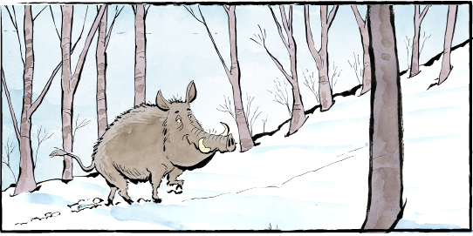
Comprehension Check

Write the letter of the best answer in the space beside each question.

1. Why were wild boars brought to Canada?
a) To breed with domestic pigs. . b) To be raised and eaten.
c) To keep crops from spreading. d) To be sold as pets.
2. Wild pigs are big. They are similar in weight to which animal?
a) Wolves. b) Black bears.
c) Cows. d) Bison.
3. How many litters of piglets can sows give birth to every year?
a) Two or three. b) Six.
c) Four to eight. d) One.
4. What is a pigloo?
a) A nest made of cattails. b) A den in the wetland.
c) A burrow under tall grass. d) A tunnel in a snowbank.
5. Why does hunting wild pigs not work?
a) They will attack humans when they hear guns.
b) They are very fast and cannot be caught.
c) They scatter when they hear guns.
d) They are too numerous.

Language Focus

Synonyms are words that have almost the same meaning.
For example: Synonyms for big: large, huge, gigantic

A. Circle the two synonyms for each set of words:
1. toasty chilly cool comfortable
2. walk crawl stroll run
3. argue scare confuse frighten
4. bravery honesty courage winner
5. cook drink eat munch
B. Write a synonym for each of the following underlined words:
1. It seemed like a good idea.
2. Wild pigs eat bird eggs and small animals.
3. They can transmit disease to humans.
4. Wild pigs are tremendously destructive.
5. They are incredibly smart.
6. They are hard to track.
7. Trappers use bait to lure pigs into a corral.
8. The wild pigs hide in thick cover.
9. Some wild pigs evade the hunters.

