Articles and Questions
Each issue of The Canadian Reader includes:
1) a PDF file (the complete document) and
2) a Word file that contains only the articles and questions. This file does not contain an Answer Key.
This Word file allows students to complete assignments using a computer either at school or at home. Teachers can assign all or parts of the file by email attachment or a school website. The Word file also allows teachers to:
• easily modify and format content including changing fonts and text sizes
• create a PDF document and use Adobe Reader's 'Read Out Loud Mode'
• save paper and copying costs and help protect the environment
• promote and encourage students’ computer skills

Password Security
There are three ways to access the data in this password protected file:
1) Select the data you wish to Copy and then Paste it into any word processing program. Use Select All to copy the entire document.
2) Import the entire Word file into LibreOffice (or another similar program) and then save as a new file
3) To remove the password from a protected Word file, use Save As to make a new copy of the file. You can then change the Security settings and remove the password.
https://help.libreoffice.org/Common/Using_Microsoft_Office_and

What Else Can You Do With The Word File?
#1) Once the password is removed you can easily upload the file to Google Docs and share it with students or other teachers. See how here:
https://support.google.com/drive/answer/2424368?hl=en
#2) Translate the uploaded document into another language. (see Tools>Translate document). Google Docs will create a new copy of the original file but you will need to edit the document to suit your requirements. Google Docs can translate into over 100 languages including Spanish, Mandarin, German, etc. See how here:
https://support.google.com/docs/answer/187189?hl=en&co=GENIE.Platform=Desktop

3-5 Key Ideas/Insights
These ideas are important for me
(or others) to know because..
I helped myself understand by…
How well did I understand what I read?
Now, I’m wondering…
Oh, Rats!
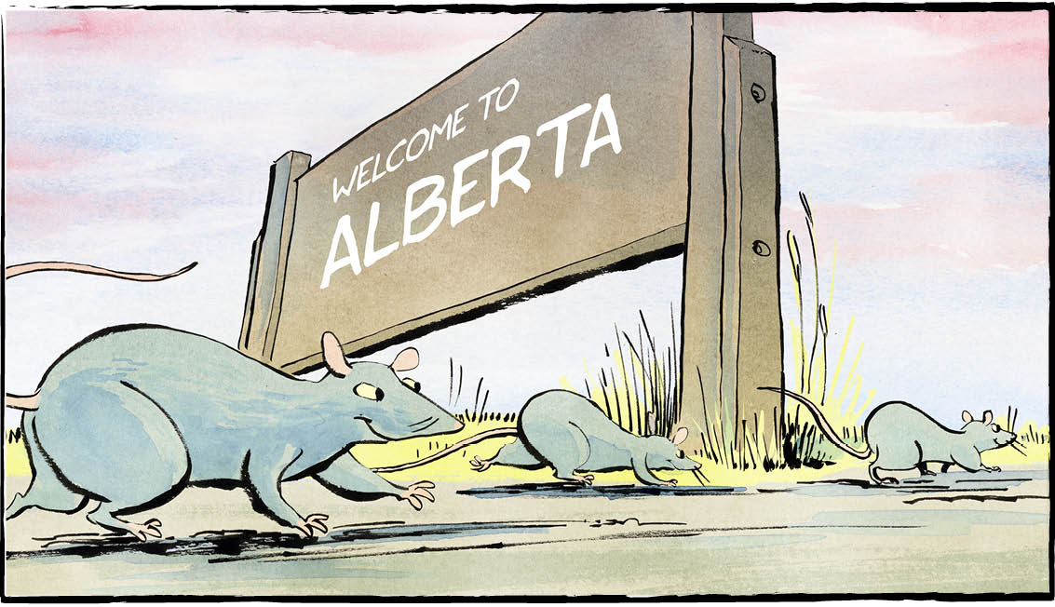

Do you smell a rat? Probably not if you live in Alberta. It’s Canada’s only rat-free province. No rats allowed! Folks there make sure the rodents are not welcome. They’ve been doing it for over 70 years.
A menace
Alberta’s rat control program was launched in 1950. That’s when rats were discovered on a farm near the Saskatchewan border.
They were officially declared pests. Albertans received leaflets in the mail about this new “menace.” Radio broadcasts warned about the threat posed by rats.
Alberta set up a rat control zone along its border with Saskatchewan. That 600-kilometre corridor is still in place today. The government hires rat inspectors to patrol the corridor.

On the lookout
It’s not that rats don’t ever sneak into Alberta. Occasionally, they do. Usually they hitchhike in a vehicle coming from B.C. But they aren’t allowed to take up residence.
Albertans know to keep watch. If they spy a rat, they contact the rat hotline. The rat control inspectors sweep in.
Usually the rat sighting is a false alarm. It’s not a rat at all — just a case of mistaken identity. It might be a muskrat, a different rodent entirely. Or a gopher. Maybe even a mouse.
“Albertans have never lived with rats,” says the rat patrol manager. “So they don’t know exactly what they look like.”
But about 30 rats — actual rats — are discovered each year. The rat inspectors quickly eradicate them.
“I’m encouraged because people are aware of the program,” says the manager.
Albertans are “all very proud of the fact that we’re rat-free.”
About rats
According to Alberta’s rat control website, rats are the most destructive animals in the world. They eat farmers' crops. They destroy property. They spread diseases.
Rats must chew continuously to wear down their front teeth. If not, the teeth can grow five to ten centimetres per year. They chew plywood, wood timbers, plastic panelling, frozen ground, and even concrete. They chew holes in the walls and floors.
Norway rats are the most common rat species. They are also the biggest, about 40 centimetres long. Their tail is shorter than their body.
Black rats, also called roof rats, are slightly smaller. Their tail is longer than their body. They are more common in B.C. They don’t normally cross the Rocky Mountains into Alberta. But sometimes they catch a ride on a transport truck.
A couple of rats can quickly become an infestation. That’s why Albertans need to stay vigilant. A Norway rat can produce up to 12 litters per year. Each litter has 12 to 18 offspring.
You do the math!

Can you name other animals that eat crops, destroy property, or spread disease?



Comprehension Check

Mark the statements T (True) or F (False). If a statement is true, write one fact to support it on the lines below. If a statement is false, write the word or words that make it true on the lines below.

1. Alberta’s rat control program was launched in 1950.

2. If Albertans spy a rat, they contact the police.

3. About 30 actual rats are discovered in Alberta each year.

4. Albertans are disappointed that the province is rat-free.

5. Rats are the most destructive animals in the world.

6. A rat’s teeth can grow five to ten centimetres per year.

Language Focus

An adjective is a word that describes a noun.
For example: Wild (animals) are fascinating.
A. In the sentences below, underline the adjective(s) and circle the noun(s).

1. Rats are considered to be destructive animals.

2. Rats can spread infectious diseases.

3. They chew large holes in the walls and floors.

4. About 30 unwanted rats are discovered each year.

5. Rats are big pests.

6. Their short tail looks like a strip of leather.

7. Rats are smart.

8. Albertans received informative leaflets in the mail.

9. They chew plywood, wood timbers, plastic panelling, frozen ground and even concrete.

10. Rats were discovered on a large farm near the border.

B. Now, rewrite five of the sentences above, replacing the adjectives with your own.

In what ways do adjectives make writing stronger?
A New Kind of Ride
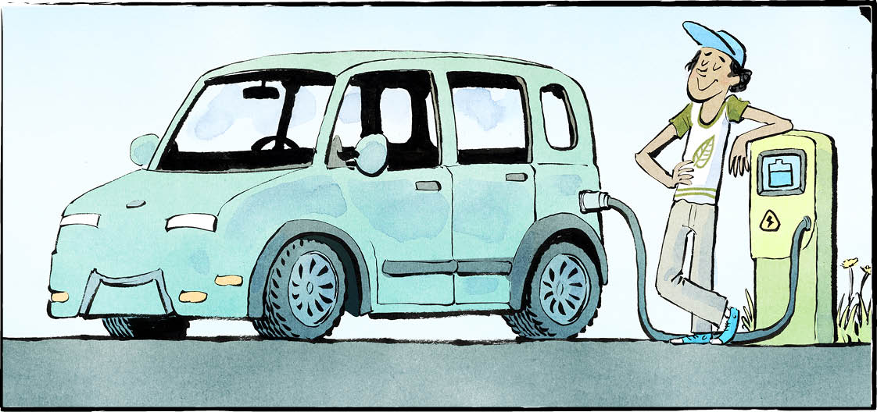

Ever driven in an electric car? It’s quiet. No motor noise. No exhaust spewing out pollution. Instead, this car runs on an electric battery. Plug it in, charge it up, and you are good to go!
Soon we’ll all be more familiar with electric vehicles (EVs). Plenty of people will be driving them. It’s part of Canada’s climate change plan.
“We know we need to cut emissions. We know we need to reduce pollution,” said Prime Minister Trudeau. “And one of the best ways of doing that is to get more clean cars on the road.”
The government has set targets. By 2026, 20 percent of all new vehicles sold must be EVs. By 2030, this rises to 30 percent. By 2035, all new vehicles will be EVs.
Your family may continue to drive its
gas-powered car for a while. But you’ll be sharing the road with more EVs.
Fill ‘er up — with electricity
We can’t just snap our fingers and switch the country to electric vehicles. A few things need to be in place.
First, we need to have enough EVs for people to buy. They need to be available. At present, that’s a problem. If you want to buy an electric vehicle, you might have a long wait.
But carmakers are ramping up production. There are even plans to make electric vehicles at factories in Ontario.
Second, we need to have enough charging stations. Some people will be able to plug in their cars at home. But what about people living in apartment buildings? How do they plug in their cars? Or what about people who are driving on vacation?
You’ve probably begun seeing public charging stations where you live. We’ll need more — all across the country. The government has promised funding for thousands more stations.
Batteries
EVs run on batteries. To make enough batteries, Canada will need a supply of nickel and other minerals. Luckily, Canada has these mineral resources — in the ground. The government plans to invest billions to build mines and refineries.
Sticker price
One reason not everyone is jumping into EVs? They’re expensive! Currently, EVs cost more than gas-powered vehicles.
But they are cheaper to run and maintain. Over the long term, they actually cost less.
There are no gasoline costs. That means that as the price of gas rises, EVs look better and better.
What’s the biggest reason to switch to an EV? Look at its exhaust pipe. What? You can't see it? That’s because there isn’t one.
There’s no exhaust. No pollution. No carbon emissions. This is a clean, green machine.
It’s our ride into a net-zero future. Buckle up.

Some Canadian rail companies are now testing electric locomotives.

As you see it, what is the importance of EVs?

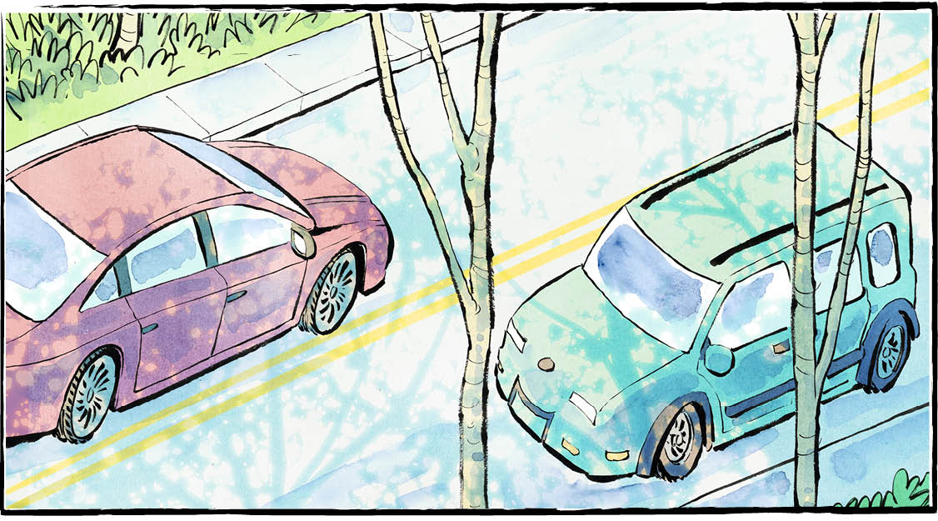
Transportation is the second-highest source of greenhouse gas emissions in Canada, after the oil and gas industry.

Comprehension Check
Answer the questions below in complete sentences:
1. What do electric cars run on?

2. What percentage of all new vehicles sold by 2026 must be EVs?

3. The government has promised funding for what important equipment?

4. What is one reason why not everyone is purchasing EVs?

5. As the price of gas rises, EVs look better and better. Why?

Language Focus
Match each word from the list below with its correct definition:

exhaust familiar target continue available
funding promise expensive pollution

1. well known
2. costing a lot of money
3. waste gas expelled from an engine
4. a substance that is harmful or poisonous to the environment
5. an objective towards which efforts are directed
6. able to be used or obtained
7. to persist in an activity
8. the assurance that someone will do a particular thing
9. money provided for a particular purpose
Canada: A Safe Haven


What would it be like to flee your home? Suppose you had to seek safety in another country. Learn a new language. Go to a new school. Start a new life. All while worrying about friends and relatives you left behind.
In early May, a plane arrived in St. John’s, Newfoundland and Labrador. It carried 166 refugees from Ukraine. Fifty-five were children.
They were greeted by cheering crowds waving Ukrainian flags. Students from a junior high school created welcoming posters.
“I just want all the Ukrainians to feel welcome here in Canada,” said one of them, a Grade 8 student.
The province’s premier said it was a proud day for the province.
“These are people who have lost their homes. Many [homes]… have been destroyed by missiles. They have no place to call home. We want to provide a home for them.”
War in Ukraine
The refugees left a country devastated by war. The Russian army invaded Ukraine on February 24th. Ukrainian forces have been fighting back ever since. Countries such as Canada have been supporting Ukrainian efforts.
The war has destroyed buildings, bridges, hospitals, schools, and entire towns. Residents have sheltered in basements and subway stations. Thousands of ordinary Ukrainians have been killed or wounded. Many have fled the violence.
The United Nations says nearly six million Ukrainians have left the country. Some 3.5 million of them have crossed into neighbouring Poland. That country can’t care for them all.
Welcome to Canada
Canada has agreed to accept thousands of Ukrainians. Some will just be here for a short time. When the war is over they want to return home. Others will settle in Canada permanently.
By May 9th, 19,000 Ukrainians had arrived in Canada. Tens of thousands more will be arriving.
Why is Canada a good choice for refugees? Many people of Ukrainian descent already live here. Some still speak the Ukrainian language.
These Ukrainian-Canadians fled their homeland in the past. They chose to come to Canada for a better life. Many settled on the Prairies. They helped to build this country.
Now they are helping a new wave of Ukrainian refugees to settle in Canada. In some cases, the people they are welcoming are actually relatives.
Yeah! Let’s do that!
“I’m happy!” said one of the refugees after arriving in St. John’s. “I got a job on my first day. It’s just perfect.”
Another refugee also sounded upbeat.
“They offered me a flight. I was like, “Yeah! Let’s do that! I’m going to Newfoundland.”
It won’t all be easy, however. Immigrants face many challenges. What’s more, newcomers worry about their family and friends still in Ukraine. But at least here they are safe.
“We will welcome them with open arms,” says the Canadian government minister in charge of immigration.

As you see it, what makes Canada a great country to live in?

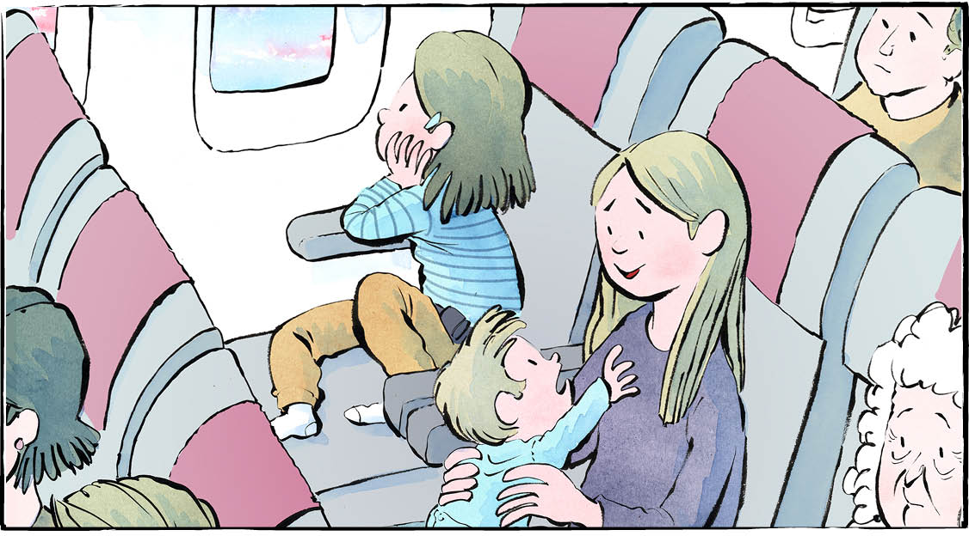

Comprehension Check

Write the letter of the best answer in the space beside each question.
1. Where did the plane carrying Ukrainian refugees land?
a) Gander. . b) Toronto.
c) Halifax. d) St. John's.
2. What has destroyed many Ukrainian homes?
a) Missiles. b) Bombs.
c) Tanks. d) Gunfire.
3. What happened on February 24th?
a) The Russian army invaded Ukraine.
b) A plane of refugees arrived in St. John’s.
c) Canada agreed to accept thousands of Ukrainian refugees.
d) One of the refugees got his first job.
4. According to the United Nations, how many Ukrainians have left the country?
a) 19 thousand. b) Six million.
c) 3.5 million. d) 166.
5. Why is Canada a good choice for refugees?
a) There are a lot of jobs in Canada.
b) Refugees are greeted by cheering crowds waving Ukrainian flags.
c) Many people of Ukrainian descent already live here.
d) Canada has agreed to accept thousands of Ukrainians.

Language Focus
How many new words can you make using the letters from each of the words in the bubbles?





