Student Articles

Each issue of ***Building Bridges*** includes:   
  
1) a PDF file (the complete document) **and**

2) a Word file that contains **only** the articles and questions. This file does **not** contain an Answer Key.

This **Word** file allows students to complete assignments using a computer either at school or at home. Teachers can assign all or parts of the file by email attachment or a school website. The **Word** file also allows teachers to:

• easily modify and format content including changing fonts and text sizes

• create a PDF document and use Adobe Reader's 'Read Out Loud Mode'

• save paper and copying costs and help protect the environment

• promote and encourage students’ computer skills

Access Data

There are two main ways to access the data in this Word file:

1) Open the **Word** file and select the data you wish to **Copy.** Then **Paste** the data it into any word processing or email program. Use **Select All** to copy the entire document.

2) Most word processing programs will open **Word** files. You can use **LibreOffice** or **Open Office** (or another similar free program) to open and save **.docx** Word files.

See: [www.libreoffice.org/discover/libreoffice/](http://www.libreoffice.org/discover/libreoffice/) [www.openoffice.org](http://www.openoffice.org)

What Else Can You Do With The Word File?

#1) You can easily upload the file to Google Drive and share it with students or other teachers. **See how here:**

<https://support.google.com/drive/answer/2424368?hl=en>

#2) Translate the uploaded document into another language. (see **Tools>Translate document**).Google Docs will create a new copy of the original file but you will need to edit the document to suit your requirements. Google Docs can translate into over 100 languages including Spanish, Mandarin, German, etc. **See how here:**

<https://support.google.com/docs/answer/187189?hl=en&co=GENIE.Platform=Desktop>

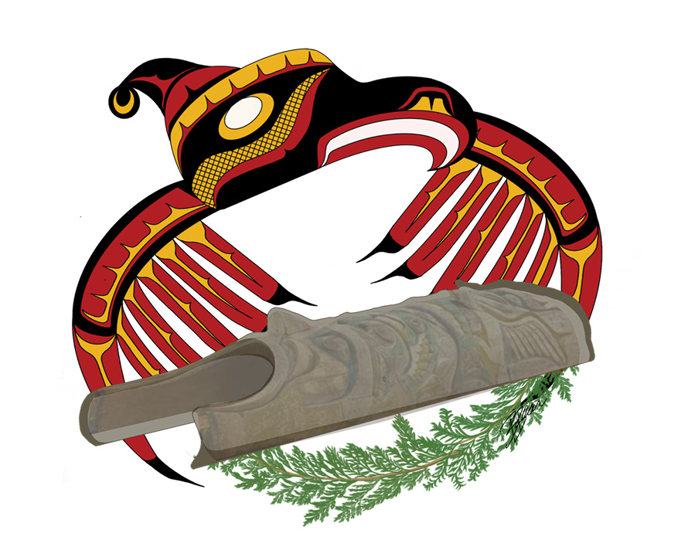

**A Totem Pole Returns Home**

On February 13, more than 100 **Nuxalkmc** traveled from Bella Coola to Victoria. The purpose of their trip? To reclaim their totem pole from the Royal BC Museum.

Some members of the group drummed and sang. Some walked through the crowd **smudging**. But all were there to witness one of their totem poles start its journey back to their community. It had been taken from a village on the central coast of B.C. over a century ago.

The totem pole is just over five metres high and a metre wide. It had been kept in the Totem Hall on the museum’s third floor. A crane moved it after the walls and windows of the museum were removed.

When the totem pole was lowered to the ground it was returning to Mother Earth. Nuxalkmc sang the Thunder Song to celebrate the big occasion.

Mara Pootlass has family connections to the pole. She said, “There is a really warm feeling in my heart… I wanted to cry for joy because I could feel the spirit.”

The Snow family pole was carved by Nuxalk Hereditary Chief Deric Snow’s great-grandfather in the mid-1800s. At first, it was an entrance pole to the Snuxyaltwa family’s longhouse. Later it was used as a grave post for a family grave. Eventually, in 1913, it was taken from a burial site without permission and added to the museum’s collection.

“We all cried when it landed on the ground,” said Chief Snow. “It was the feeling when your emotions reach the highest point of your life. I’ve never dreamed we would be able to do this.”

**A long road to repatriation**

The process of returning the totem pole began in October 2019. That was when leaders of the Nuxalk First Nation visited the museum to ask for the **artifact** to be **repatriated**. According to the museum’s records, it had been sold to the museum in 1913 for 45 dollars.

Clyde Tallio is a teacher of traditional Nuxalk culture. He say this information is incorrect.

“Things like this wouldn’t be sold, that’s not our tradition,” he stated.

At the time of the visit, Jack Lohman was the museum’s CEO. He told the Nuxalk Nation the museum would return the totem pole, along with several other items. He said to the many Nuxalkmc visiting the museum, “I recognize as the leader of this museum that this pole needs to return back to its territory – that these treasures need to return back to their territory.”

However, no action was taken, so in January 2022 Chief Snow launched legal action against the museum. He said the museum’s failure to return his great‑grandfather’s totem pole had been hurtful to members of his community.

“It’s a beautiful pole,” he told CBC. “It doesn’t belong in the Royal Museum, it doesn’t belong in any museum.”

Janet Hanuse is the museum’s vice president. She explained that the process had been held up because of the COVID-19 pandemic. Then, she pledged to restart the repatriation process.

**The journey home**

The 1000-kilometre journey from Victoria to Bella Coola took seven days. Along the way, the Nuxalk Nation members and the totem pole stopped to visit other Nations.

On February 15, hundreds of tribal members at the Williams Lake First Nation in Secwepemc territory honoured this act of repatriation. Elder tribal women blessed those present with a healing song and blessed the pole with fir boughs.

Williams Lake First Nation Chief Willie Sellars explained, “As we were drumming the welcoming song, the Elder women from our nation suddenly, without being asked, got up and began doing the welcoming dance… It broke me down. It got very emotional for a lot of people because we don’t see these things happen often.”

He continued, “The **legacy** and history of **Residential Schools** and the trauma that was inflicted on my ancestors and Elders that are still alive today has never left us. To see them still be able to hold on to our traditions and pass it down from generation to generation makes you so proud to be Indigenous.”

Then on February 16, dozens of people traveled to the outskirts of Bella Coola to witness the pole’s arrival. Chief Snow explains, “We were greeted by about 50 Nuxalkmc cars, waiting for us to come down the hill. That’s how excited our people were.” Nuxalk member Charlene Schooner adds, “Our history is embedded in these poles, a great history, and when they’re taken, it’s almost as if it’s like our children were taken… They are part of our history.”

**The importance of returning home**

Later, on February 20, hundreds gathered for a ceremony at the Acwsalcta School gymnasium in Bella Coola. The event was celebrated with songs and dancing, followed by a feast.

Chief Snow stated that the return of the totem pole means that his great-grandfather’s spirit, which remains inside the totem pole, can now rest. “The circle of life is we never pass away,” he explained. “We’re just here for a visit and once that visit’s over, we go on to another journey and my [great-grandfather] wants to continue that journey.”

The Nuxalk Nation’s elected Chief Councillor, Samuel Schooner, stated in an email that “the repatriation of cultural property is an important way of acknowledging and reconciling the unjust treatment First Nations people have endured since contact.” He added that the return of the totem pole is a historic moment. “It’s something our families have been waiting for, waiting to be honoured and remembered in a good way and to be treated with dignity and respect, to be treated as a human.”

**About totem poles**

Totem poles are a collection of **crests**. They are usually carved from a red cedar tree by Pacific Northwest Indigenous Peoples. These crests can be human, animal, or supernatural forms. They often tell the history of a family or an event. Many longhouses have house posts. They support the main beams of the building. Other longhouses have a frontal pole. These poles are located at the main entrance.

Raising a totem pole is a ceremonial event. The ceremony is hosted by a chief and often includes a feast or potlatch. Hosting this event is a sign of wealth in many Pacific Northwest Indigenous cultures because food and sometimes gifts are provided to the guests. During the ceremony many gifts are given to the master carver and their assistants as well. The gifts are given to acknowledge their hard work and skill.

Before a tree is harvested for a totem pole it is honoured. Members of the community show gratitude and respect for the tree with a spiritual ceremony. When a carved totem pole falls or begins to decay, it is left untouched because it is a natural part of a totem pole’s life cycle. The tree will return to the Earth and provide nutrients and shelter for many other forms of life.

**The Nuxalkmc Peoples**

The Nuxalkmc Peoples’ traditional territory is in the Pacific Northwest, in what is now called Bella Coola and its surrounding areas. The Nuxalk Nation is the government of the Nuxalkmc and consists of an elected Chief and Council system, which was first imposed on First Nations through the Indian Act. The traditional language is It7Nuxalkmc.

**artifact:** a tool or other object that was made a very long time ago

**crest:** a design used as a symbol

**legacy:** something such as a tradition or problem that exists as a result of something that happened in the past

**Nuxalkmc:** the peoples of the Nuxalk Nation

**repatriation**: the act or process of restoring or returning someone or something to its country of origin, allegiance, or citizenship

**Residential Schools**: church-run, government-funded schools that operated between the late 1880s and 1996. Indigenous children were taken from their families and forced to live at these schools, which aimed to educate, convert, and integrate them into Euro-Canadian society.

**smudging:** a cultural ceremony practised by a wide variety of Indigenous Peoples in Canada and other parts of the world, involving the burning of sacred herbs (e.g., white sage) or resins

**Repatriation and Respect**

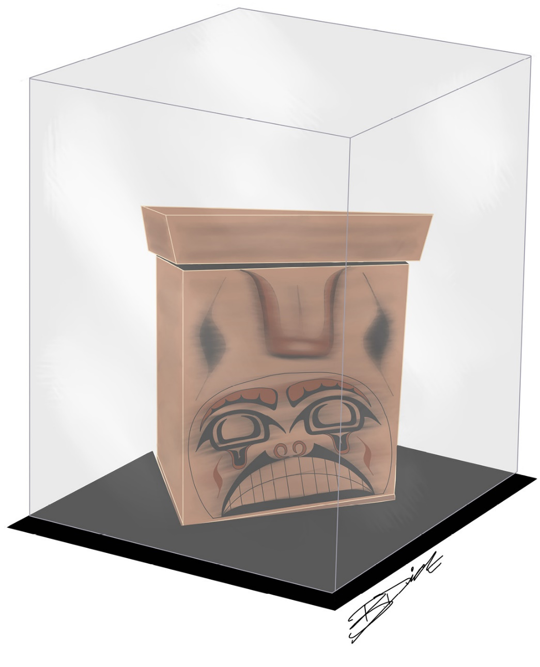

Canadian politician Bill Casey was at a Nova Scotia cultural centre. He was admiring a beautifully embroidered and beaded robe. The Mi’kmaw **regalia** was in a glass case.

Mr. Casey was surprised to learn that he was looking at a **replica**. The original robe was in a drawer at a museum in Australia! The Nova Scotia centre had been trying to get the original back from Australia for a decade. It had been sold in the early 1840s to a British army officer. He died in Australia and left the robe and other Indigenous artifacts to the Melbourne Museum in his will.

The Mi’kmaw regalia is just one of thousands of Indigenous artifacts and remains from Canada that are in museums across the country and around the world. Most of these items were collected between 1850 and 1950.

For example, a **mortuary pole** erected in a Haisla village on the north central B.C. coast in 1872 ended up in Sweden. **Monumental poles** that once stood in villages on **Haida Gwaii**, B.C. were moved to Victoria’s Royal B.C. Museum. Many ceremonial potlatch masks collected in 1881 from Kwakwaka’wakw territory on northern Vancouver Island are in a museum in Berlin, Germany.

How did these artifacts get there? Sometimes they were **legitimately** purchased or donated. Often they were stolen or taken without permission. Some collectors believed the artifacts had been abandoned by their owners and were no longer wanted.

Some ceremonial items such as ritual clothing and dancing masks were used in potlatch ceremonies. These giving feasts are practiced by Pacific Northwest Coast Indigenous Peoples. They are held to mark important events, but were banned by the Canadian government from 1885 to 1951. During the ban, potlatch artifacts were **confiscated**. Many went to museums such as the Canadian Museum of History in Gatineau, Quebec and the Royal Ontario Museum in Toronto.

When **smallpox** and other diseases brought by European settlers swept through Indigenous communities, many people died. The few that survived were often forced to abandon their villages. Collectors later took any items that were left behind, such as totem poles and burial artifacts. Some human remains were collected in the name of science. At the time, many scientists felt that grave robbing was acceptable if it was for research.

**Through a different cultural lens**

To many Indigenous Peoples, these lost artifacts are not simply “things”.

“Our treasures are family,” says Kwakwaka’wakw artist Lou‑ann Ika’wega Neel. She’s the **repatriation** specialist at the Royal British Columbia Museum in Victoria.

“To know that our family is being stored away in museum cases or in basements or attics in faraway lands has always been heartbreaking.”

Tracey Herbert leads B.C.’s First People’s Cultural Council. She is a member of the Bonaparte First Nation, and sees repatriating and taking care of these objects as her duty.

“A lot of the objects and materials in museums hold Indigenous knowledge that we need for the **revitalization** of our own arts, cultures, and languages,” she says.

Human remains are even more sensitive. Ms Herbert says keeping them in museum drawers or examining them for science is disrespectful.

The Haida people have been leaders in repatriating ancestral remains to their homeland of Haida Gwaii. The website of their Repatriation and Culture Committee explains why this work is so important.

“Our ancestors are our relatives and we have a deep connection to them. We are who we are today because of them. We believe that as long as the remains of our ancestors are stored in museums and other unnatural locations far from home, that the souls of these people are wandering and unhappy. Once they are returned to their homeland of Haida Gwaii and are laid to rest with honour, the souls can rest and our communities may heal a bit more.”

**Winds of change**

In recent years, we are seeing a global shift in the attitude of museums.

“For years, **restitution** was a no-no word in the museum language,” says John McAvity, executive director of the Canadian Museums Association. “This is changing fast, and it’s about time.”

The 2007 **UN Declaration of Rights of Indigenous Peoples (UNDRIP)** states that Indigenous Peoples have the right to have their cultural, intellectual, religious, and spiritual property returned to them.

Canada’s 2015 Truth and Reconciliation Commission (TRC) report called for museums to determine whether they are **in** **compliance** with the UN Declaration. In 2018, the Canadian Museums Association set up a working group to respond to this call to action.

In 2016, the Royal BC Museum launched a repatriation program in consultation with the First People’s Cultural Council in B.C. Since 2021, the museum has completed 11 repatriation requests and engaged in ten Outreach and Research Visits. Eighteen more repatriation requests are expected to be completed by 2025 and 7 more Outreach and Research Visits.

According to Ms Neel, the museum will return hundreds of ancient remains and sacred cultural objects to First Nations communities. She says the collection includes many artifacts that were confiscated under the potlatch ban and shouldn’t have been taken in the first place.

At the other end of the country, Nova Scotia MP Bill Casey has introduced a bill called the Aboriginal Cultural Property Repatriation Act. He hopes it will make it easier for Indigenous people to get their cultural property back from museums. It provides money to pay for transferring and storing these objects.

“I do not pretend to be able to capture the entire meaning that artifacts have to First Nations peoples, but I know it is so important for them to have them back,” he said.

Heather Stevens heads operations at the Millbrook Cultural and Heritage Centre in Nova Scotia where Mr. Casey admired the replica of the Mi’kmaw regalia. She says it would be “amazing” to be able to display the actual regalia and tell visitors about its meaning.

“There are no words really to explain how I would feel to have it here,” she said. “It was created by one of our ancestors and to have it back to where it originally came from just gives us that connection again to our ancestors.”

**Repatriation – a long and complex journey**

The process of repatriation is not simple. It’s not like a community can just ask for something back and the museum will hand it over. Sometimes the museum doesn’t actually own the artifacts. The collection may be owned by the city or country where the museum is located.

Research may need to be done to identify which Indigenous community is the rightful owner. Members of that community must be consulted to determine how the repatriation should take place. There are practical matters to think about. Where will the items be stored? How will travel be paid for? There may also be special **protocols** and ceremonies, especially for human remains.

For example, here’s how the Haida Repatriation Committees describe their repatriation journey.

Beginning in the 1990s, the Haida approached Canadian, U.S., and British museums to request the return of their ancestors’ skeletal remains. In one case, 148 ancestors were held at the Canadian Museum of Civilization in Ottawa. Another 160 ancestors were in a vault at the Field Museum in Chicago, USA.

How did so many Haida ancestors end up in museums? Before contact with Europeans, tens of thousands of Haida people lived in villages on Haida Gwaii. Then smallpox **decimated** many of the communities. Only a few hundred people survived. Many survivors had to leave their villages. The human remains and artifacts left behind were later taken by archaeologists and collectors.

The Haida population on Haida Gwaii recovered and now numbers about 5000. They have established Repatriation Committees led by hereditary leaders, Elders, and band and village councils. The committees coordinate the process of bringing the ancestors home. Every part of the process is guided by the wishes of the Haida community.

The Repatriation Committees raise funds. **Delegations** travel to wherever their ancestors are held to bring them home. The delegations may include Haida Elders, chiefs, artists, and researchers.

The delegation prepares the ancestors for the journey home. Then, there is a feast and signing ceremony. The Haida include museum staff in their work and ceremonies, if possible.

“By the end of each repatriation, the employees of the museum are always so thrilled to have been part of the process and you can see that they understand and are involved from their hearts.” (Skidegate Reparation and Culture website)

When they bring their ancestors home, the Haida wrap them in button blankets and cedar bark mats. They place them in bentwood boxes painted with Haida designs. The ancestors are buried with traditional ceremonies. The community speaks to the ancestors and prays for them in their Haida language. Elders and cultural historians teach the traditional songs, dances, and rituals. The event ends with a feast in honour of the ancestors.

“And perhaps most important, after each ceremony, one can feel that the air has been cleared, that spirits are resting, and our ancestors are at peace, and one can see that healing is visible on the faces of the Haida community.” (Skidegate Repatriation and Culture Committee website)

The remains of over 600 Haida ancestors have been returned to date. Through this process, the Haida have also built good working relations with museums across North America and in the United Kingdom. They are still working on repatriating their ancestors from European museums and private collections.

**The broader picture**

Repatriation is not just about lost artifacts held in museums. It’s also about acknowledging the historical events that led to the loss of this Indigenous property.

**Colonial** attitudes and historical injustices such as the Residential School System and the ban on potlatches played a big role. They helped create a climate where Indigenous Peoples and their cultural practices were not respected. Indigenous ways of knowing and being were dismissed and denied. That allowed non-Indigenous people and institutions to collect and remove cultural heritage without permission. It allowed them to take artifacts and remains without worrying about Indigenous governance and property ownership.

Repatriation turns that around. It’s about **reconciling** with the past, making amends, and furthering the healing process. It’s a way of respecting the cultural heritage of Indigenous peoples.

“We’re making things right,” says Haida Repatriation Committee member Gaagwiis Jason Alsop.

**colonial:** relating to a system or period in which one country or group rules another

**confiscated:** taken without permission or consent especially by public authority

**decimated**: reduced drastically in number

**delegation**: a group of people who represent a country, government, or organization

**Haida Gwaii:** a group of islands off the coast of British Columbia

**in compliance:** being in agreement with the expectations, guidelines, or rules of another

**legitimately:** in a lawfully recognized manner

**monumental pole:** tall cedar pole carved with figures or symbols by Indigenous Peoples of the Northwest Coast to symbolize or commemorate ancestors, cultural beliefs that recount familiar legends, clan lineages, or notable events; also known as a totem pole

**mortuary pole:** a type of monumental (or totem) pole that has a cavity in the top to hold a burial box containing the remains of a chief or high ranking person

**protocol:** a set of rules for the correct way to behave on formal occasions

**reconciling**: finding a way to make ideas, beliefs, needs, etc. that are opposed to each other capable of existing together

**regalia:** traditional clothing worn for a ceremony or special occasion

**repatriation**: the act or process of restoring or returning someone or something to its country of origin, allegiance, or citizenship

**replica:** a copy that is not the original

**restitution**: the act of returning something that was lost or stolen to the person it belongs to

**revitalization:** the act of bringing again into activity and prominence

**smallpox:** a highly contagious and serious disease caused by a poxvirus transmitted from person to person that causes a high fever, a characteristic rash, and may kill about one-third of those infected

**United Nations Declaration of Rights of Indigenous Peoples (UNDRIP)**: a non-legally binding declaration created by the United Nations as an aspiration for how Indigenous individuals and Peoples should be treated

