Articles and Questions
Each free article of The Canadian Reader includes:
1) a PDF file
and
2) a Word file
These files contain only the article and questions. They do not contain Answer Keys.
This Word file allows students to complete assignments using a computer either at school or at home. Teachers can assign all or parts of the file by email attachment or a school website. The Word file also allows teachers to:
• easily modify and format content including changing fonts and text sizes
• create a PDF document and use Adobe Reader's 'Read Out Loud Mode'
• save paper and copying costs and help protect the environment
• promote and encourage students’ computer skills

What Else Can You Do With The Word File?
#1) You can easily upload the file to Google Docs and share it with students or other teachers. See how here:
https://support.google.com/drive/answer/2424368?hl=en
#2) Translate the uploaded document into another language. (see Tools>Translate document). Google Docs will create a new copy of the original file but you will need to edit the document to suit your requirements. Google Docs can translate into over 100 languages including Spanish, Mandarin, German, etc. See how here:
https://support.google.com/docs/answer/187189?hl=en&co=GENIE.Platform=Desktop

Migrating Monarchs
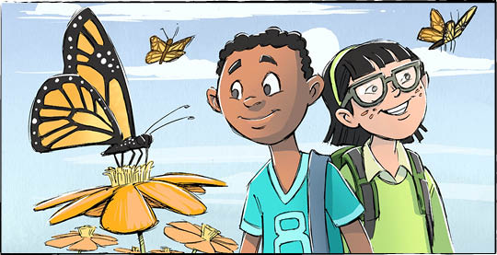

The next time you see a monarch butterfly, look closely. It may be wearing a microchip.
The microchip, inside a tiny transmitter, sends a signal about 100 metres. The signal is read by iPhones using the Project Monarch app. When the signal reaches an active iPhone, its time and location are recorded. That data is uploaded through the app.
One signal at a time, scientists are unlocking the mysteries of monarch butterfly migration.
“Every detection is a window into something no scientist has ever been able to see before,” said Dr. Sean Burcher, a scientist involved with the project.
Project Monarch
Groups from Canada, the United States, Mexico, and the Caribbean worked together on Project Monarch. Environment and Climate Change Canada and Birds Canada are both involved.
Last fall, about 400 microchipped monarchs started south from Canada and the United States. Scientists tracked their paths.
This spring, in Mexico’s Monarch Butterfly Biosphere Reserve, scientists microchipped more than 160 monarchs. Those butterflies are already winging their way north.
Some of the 400 butterflies that flew south are making their way north again, too! This may be the first time one monarch is tracked all the way south and back again.
Flying south
Monarchs migrate up to 5000 kilometres. They are the only butterflies with such a long, two-way migration. They start as far north as Canada and go as far south as Mexico.
One “super” generation of monarchs flies south. The return trip happens over 3-4 generations.
Some monarchs fly partway north, then stop to lay eggs before dying. Egg becomes caterpillar. Caterpillar forms chrysalis. Finally, the chrysalis hatches a new butterfly. The new butterfly continues the journey north.

A tiny transmitter
Attaching a tiny transmitter to a butterfly isn’t easy. The butterfly must be held carefully to protect its wings. The transmitter is glued to the butterfly’s thorax, or body. Some scientists use eyelash glue!
The transmitter is powered by a solar panel the size of a grain of rice. Each transmitter weighs about 60 milligrams. An adult monarch butterfly weighs about 500-600 milligrams.
Don’t worry. Scientists made sure the transmitter would not be too heavy for the monarchs. They want to observe the monarchs’ behaviour. They don’t want to change it.
One butterfly’s journey
Until now there was no way to track a single butterfly’s path.
Now, we can learn how far a butterfly travels in a day. We can see where it stops to rest. We can see how weather and landscape shape its journey. We can learn where more butterfly habitat is needed.
Monarchs face many threats, including habitat loss, climate change, and pesticides. The more we know about their journeys, the better we can protect them.

You probably already know that many birds migrate. Did you know monarchs do the same?

As you see it, what is the importance of studying butterfly migration?

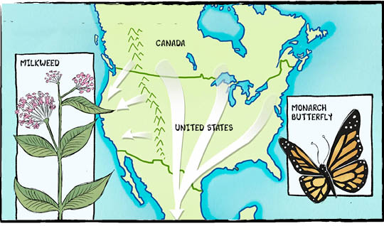

Comprehension Check
Write the letter of the best answer in the space beside each question.

1. What does the microchip on the monarch butterfly do?
a) It helps the butterfly fly faster.
b) It changes the butterfly’s colour.
c) It sends a signal that can be tracked.
d) It protects the butterfly from predators.
2. What is special about monarch butterfly migration?
a) They only travel at night. b) They fly in small groups only.
c) It is very long. d) They never stop to rest.
3. Where do monarch butterflies travel during migration?
a) Between Mexico & Europe. b) Between Canada & Mexico.
c) From the U.S. to Africa. d) From the Caribbean to Asia.
4. How do scientists attach the transmitter to the butterfly?
a) They tie it to the wings. b) They place it inside the body.
c) They clip it to the legs. d) They glue it to the body.
5. Why is tracking monarch butterflies important?
a) To learn how to protect them. b) To make them fly faster.
c) To change their route. d) To improve technology.

Language Focus
A definite article (the) is used when you talk about something specific
(For example: The dog is sleeping on the couch.)
Indefinite articles (a, an) are used when you talk about something not specific.
(For example: I saw a cat in the garden. She ate an apple)
Use "a" before words that start with a consonant sound. Use "an" before words that start with a vowel sound.

Write the article the, a, or an in the blanks below:
1. ______ next time you see ______ monarch butterfly, look closely.
2. It may be wearing ______ microchip.
3. Scientists made sure ______ transmitter would not be too heavy.
4. ______ transmitter is powered by ______ solar panel the size of ______ grain of rice.
5. ______ adult monarch butterfly weighs about 500–600 milligrams.

Now write three sentences of your own using the, a, and an.
1.
2.
3.

