Articles and Questions
Each free article of The Canadian Reader includes:
1) a PDF file
and
2) a Word file
These files contain only the article and questions. They do not contain Answer Keys.
This Word file allows students to complete assignments using a computer either at school or at home. Teachers can assign all or parts of the file by email attachment or a school website. The Word file also allows teachers to:
• easily modify and format content including changing fonts and text sizes
• create a PDF document and use Adobe Reader's 'Read Out Loud Mode'
• save paper and copying costs and help protect the environment
• promote and encourage students’ computer skills

What Else Can You Do With The Word File?
#1) You can easily upload the file to Google Docs and share it with students or other teachers. See how here:
https://support.google.com/drive/answer/2424368?hl=en
#2) Translate the uploaded document into another language. (see Tools>Translate document). Google Docs will create a new copy of the original file but you will need to edit the document to suit your requirements. Google Docs can translate into over 100 languages including Spanish, Mandarin, German, etc. See how here:
https://support.google.com/docs/answer/187189?hl=en&co=GENIE.Platform=Desktop

The Wreck of The Edmund Fitzgerald
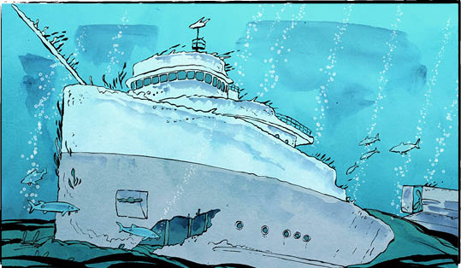

November 9, 1975. The huge ship set out from Superior, Wisconsin, headed east to Detroit, Michigan.
It had made the trip across Lake Superior many times before. The lake is an important shipping route.
This time, the ship’s load of iron ore made it sit low in the water.
A storm was brewing. The captain chose a route near Canada’s shoreline. The rocky highlands would help protect ship and crew.
The ship travelled east through a day and a night. Wind and waves grew. By morning, winds reached 50 knots (over 90 kilometres per hour). Each hour, the storm strengthened. The ship took damage but kept going.
By evening, the ship had reached the east end of Lake Superior. There was nothing to break the hurricane-force winds. Heavy weather on the Great Lakes is dangerous. Waves there are steeper than on the ocean, and closer together.
The captain tried to reach shelter. After 7 p.m., radio contact was lost. The ship, and its crew of 29 men, never reached shore.
Did the ship break apart? Was it swamped? Fifty years later, we still don’t know what happened. But we remember.
The Edmund Fitzgerald
Between 1875 and 1975, more than 6000 ships sank in the Great Lakes. Most Canadians can name only one. This one.
Why? Likely because the great Edmund Fitzgerald lives on in song.
In 1975, when Canadian singer‑songwriter Gordon Lightfoot learned about the shipwreck, the story moved him. He thought the 29 men who had died deserved to be remembered.
Mr. Lightfoot was working on a sea‑shanty melody at the time. He decided this was the story the song needed to tell.
The Wreck of the Edmund Fitzgerald became an unlikely hit. It didn’t have a chorus. It was six minutes long. Most popular songs were less than half that length.
The song told the ship’s story honestly. It told it with caring and respect. Maybe that was what reached people.
A legacy of safety
Mr. Lightfoot’s song drew attention to the ship’s fate. In the years that followed, rules were changed to make travel on the Great Lakes safer.
There has not been a commercial shipwreck on the Great Lakes since. Perhaps that is the Edmund Fitzgerald’s legacy.

Fifty years
November 2025 marked fifty years since the disaster. In locations around Lake Superior, people gathered to remember. There was even a memorial swim, done relay-style. The swim followed the route that would have led the ship to safety.
In 1975, the bell at Detroit’s Mariners’ Church rang out 29 times. Once for each man aboard the Edmund Fitzgerald.
This year, it rang 30 times. The thirtieth was to remember all lives lost at sea.

Why is it important to remember important historical events?

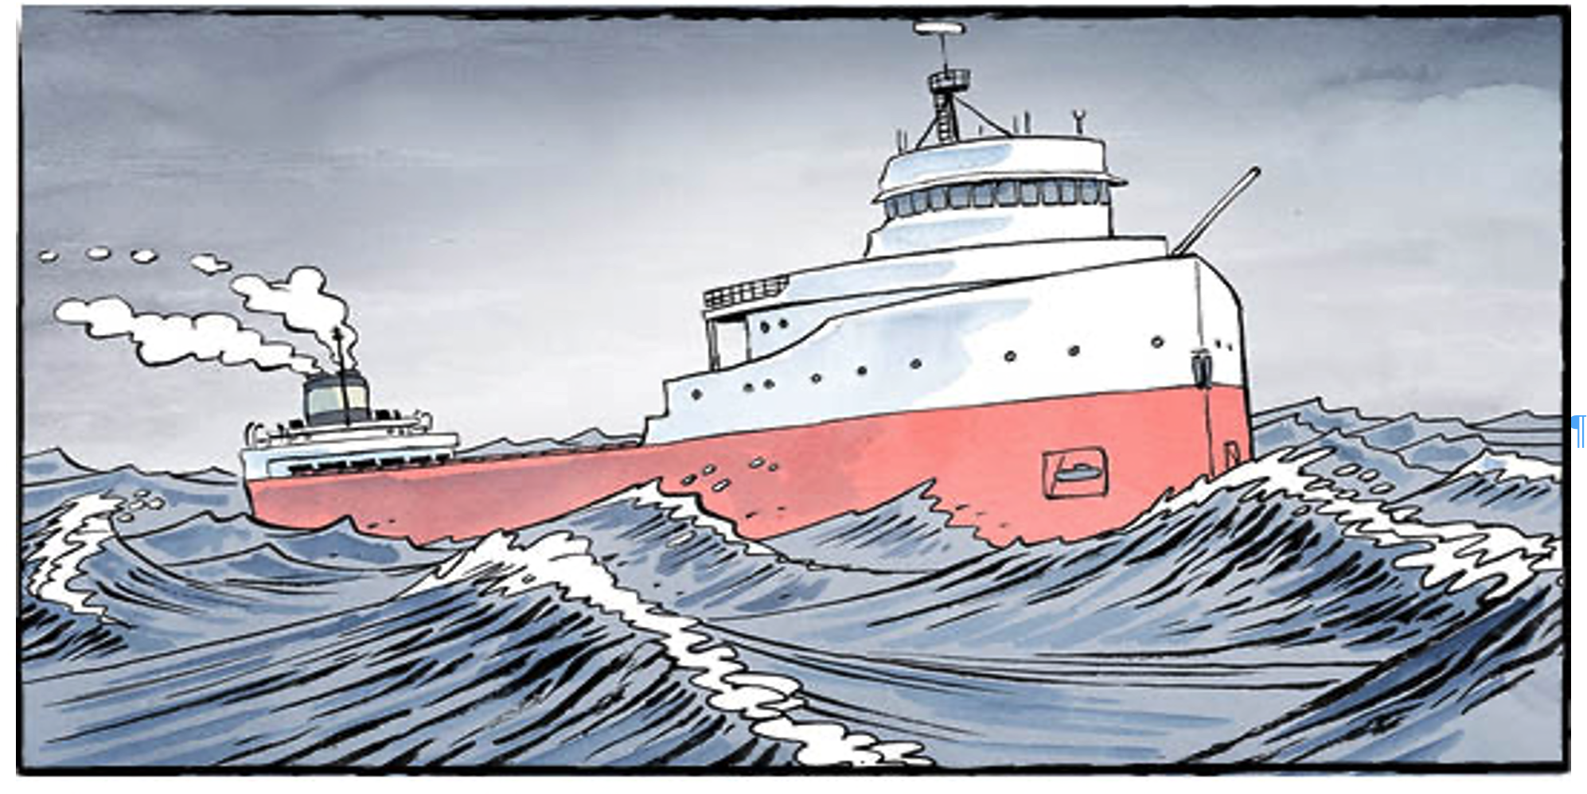
Gordon Lightfoot updated his lyrics twice, to better reflect the truth. A “musty hall” became a “rustic hall.” A line about a hatchway caving in was replaced entirely.

Comprehension Check
Mark the statements T (True) or F (False). If a statement is true, write one fact to support it on the lines below. If a statement is false, write the word or words that make it true on the lines below.

1. Lake Superior is an important shipping route.

2. The Edmund Fitzgerald was carrying iron ore when it sank.

3. The Edmund Fitzgerald is the only ship ever to sink in the Great Lakes.

4. Gordon Lightfoot wrote a song called The Crash of the Edmund Fitzgerald.

5. Twenty-nine men died when the Edmund Fitzgerald sank.

6. November 2025 marked 50 years since the ship sank.

Language Focus
An antonym is a word that means the opposite of another word.
Examples: good/bad, true/false, high/low

Now choose two pairs of words from the table above. Use each of the words in a sentence that shows its meaning.
1.

2.

3.

4.

Historical Significance
Answer the questions below in complete sentences:
1. Why is the sinking of the Edmund Fitzgerald considered historically significant?

2. What lasting impacts did the tragedy have on shipping safety, on communities around Lake Superior, or on public memory?

3. How does Gordon Lightfoot’s song help keep the memory of the 29 crew members alive?

4. What makes the song itself historically significant?

5. What does this event teach us about life on the Great Lakes, or about the dangers sailors faced?

