Articles and Questions

Each **free article** of ***The Canadian Reader*** includes:   
  
1) a PDF file

*and*

2) a Word file

These files contain **only** the article and questions. They do **not** contain Answer Keys.

This **Word** file allows students to complete assignments using a computer either at school or at home. Teachers can assign all or parts of the file by email attachment or a school website. The **Word** file also allows teachers to:

• easily modify and format content including changing *fonts* and text sizes

• create a PDF document and use Adobe Reader's 'Read Out Loud Mode'

• save paper and copying costs and help protect the environment

• promote and encourage students’ computer skills

What Else Can You Do With The Word File?

#1) You can easily upload the file to Google Docs and share it with students or other teachers. **See how here:**

<https://support.google.com/drive/answer/2424368?hl=en>

#2) Translate the uploaded document into another language. (see **Tools>Translate document**).Google Docs will create a new copy of the original file but you will need to edit the document to suit your requirements. Google Docs can translate into over 100 languages including Spanish, Mandarin, German, etc. **See how here:**

<https://support.google.com/docs/answer/187189?hl=en&co=GENIE.Platform=Desktop>

Ghost Gear

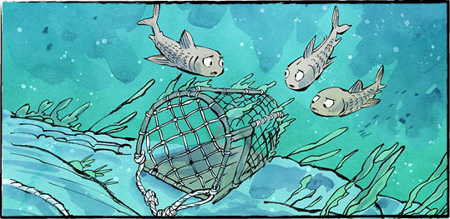

What do you think “ghost gear” is? No, it’s not a gadget for ghost hunters.

Ghost gear is fishing equipment left behind in the ocean. It includes nets and ropes. It even includes lobster traps.

Abandoned gear is a big problem! Each year, it kills about 136,000 large marine animals, such as whales, seals, and sea lions. Many smaller animals are harmed as well.

How? Ghost gear just keeps on fishing. A small fish gets trapped in a net. It becomes bait. A larger fish comes along, hunting food. It gets trapped, too. Then another, and another.

Ghost gear also ruins habitats. A single net can destroy an entire coral reef. “Wherever ghost gear lands becomes a cemetery,” says scuba diver Neyi Ibargüen.

**Where does ghost gear come from?**

Some gear is lost by accident. It can snag on rocks. It can be damaged on the sea floor. It can be blown loose by storms.

On the other hand, some gear is left on purpose. For instance, a fisher might abandon worn-out or broken gear.

**A plastic problem**

People have been fishing for thousands of years. Why is ghost gear suddenly a problem now?

It’s a matter of materials. Fishing ropes used to be made from natural fibres. Traps were built from wood. These broke down over time.

Now most fishing gear is plastic. Even the ropes are plastic-based. Deep in the ocean, plastic can last up to 600 years.

**Dangerous decay**

Ghost gear that floats on the ocean surface decays faster. That’s a problem, too. The gear breaks into smaller and smaller bits of plastic.

These plastic bits are eaten by fish, birds, and animals. Some die from it. Some become ill. When those animals are eaten, the plastics make their way up the food chain.

**Ghost(gear) Busters**

People around the world are fighting   
ghost gear.

In Colombia, trained scuba divers like Neyi Ibargüen hunt and retrieve ghost gear underwater. They are careful not to hurt habitats. Some divers even rescue whales trapped in nets.

Canada is taking action too. The federal government’s Ghost Gear Program spent more than $58 million between 2020 and 2024. Some of that money helped fund companies that recycle ghost gear.

The Saltwater Collective in Toronto is one of those companies. It turns abandoned fishing nets into fabric. The fabric is used for swimwear.

Ocean Legacy is based in British Columbia. Volunteers collect ghost gear that washes up on shore. Then the company turns it into new products. They make zippers and buttons. They even make boards for construction.

Their most popular product? Ghost gear flower pots. Talk about going green!

Every year, about 640,000 tons of ghost gear enter the world’s oceans. Weight-wise, that’s about five   
CN Towers.

What other solutions can you suggest to help reduce ghost gear?

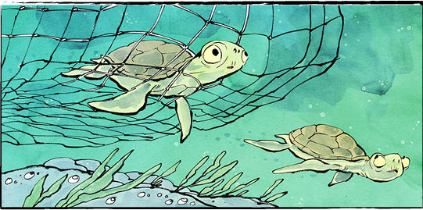

**In Canada, people must report lost fishing gear. However, only about half the gear reported lost in the past four years was found. Mostly, that included lobster and crab traps.**

**Comprehension Check**

Mark the statements **T** (True) or **F** (False). If a statement is ***true***, write one fact to support it on the lines below. If a statement is ***false***, write the word or words that make it true on the lines below.

**1.** Ghost gear includes nets, rope, and lobster traps.

**2.** Ghost gear only affects large marine animals.

**3.** Ghost gear helps habitats grow.

**4.** Ghost gear that floats decays faster than ghost gear deep in the ocean.

**5.** Ocean Legacy turns ghost gear into new products.

**6.** Ocean Legacy turns ghost gear into new products.

**Language Focus**

*Find four interesting or challenging words from the article and write the definitions.*

1

2.

3.

4

*Now use the words from above to make your own sentences.*

1.

2.

3.

4.

