Articles and Questions

Each **free article** of ***What in the World?*** includes:   
  
1) a PDF file

*and*

2) a Word file

These files contain **only** the article and questions. They do **not** contain Answer Keys.

This **Word** file allows students to complete assignments using a computer either at school or at home. Teachers can assign all or parts of the file by email attachment or a school website. The **Word** file also allows teachers to:

• easily modify and format content including changing *fonts* and text sizes

• create a PDF document and use Adobe Reader's 'Read Out Loud Mode'

• save paper and copying costs and help protect the environment

• promote and encourage students’ computer skills

What Else Can You Do With The Word File?

#1) You can easily upload the file to Google Docs and share it with students or other teachers. **See how here:**

<https://support.google.com/drive/answer/2424368?hl=en>

#2) Translate the uploaded document into another language. (see **Tools>Translate document**).Google Docs will create a new copy of the original file but you will need to edit the document to suit your requirements. Google Docs can translate into over 100 languages including Spanish, Mandarin, German, etc. **See how here:**

<https://support.google.com/docs/answer/187189?hl=en&co=GENIE.Platform=Desktop>

**Angry Hurricanes Ravage the U.S.**

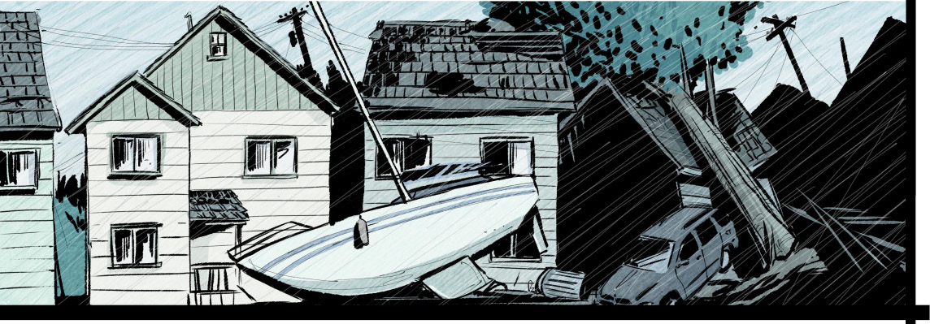

Two raging storms, Hurricane Helene and Hurricane Milton, recently walloped the Southeastern United States. They caused at least 260 deaths and changed many lives forever.

**Helene roars to life**

Helene, the first to strike, developed over warm waters in the Caribbean Sea west of Jamaica. The sleeping monster first awoke on September 23. as a tropical storm. It caused floods and mudslides across western Cuba. On September 25, it grew to Category 1 status. Its winds reached between 119 and 153 kilometres per hour. It then lashed Mexico's Yucatan Peninsula, churning up beaches and flooding tourist spots.

That was bad enough. But Helene was just revving up. **Meteorologists** watched it gain strength, and became concerned. They knew a true monster was on its way. Officials issued dire warnings. They advised residents to brace for severe flooding and catastrophic wind damage. People in the storm's path were urged to evacuate. A **state of emergency** was declared.

**Ripped apart**

Strong winds and a big **storm surge** battered many towns as the storm moved up Florida's west coast. It made landfall in the **Florida Panhandle** on September 26 as a Category 4 storm. This powerful wrecking machine had winds reaching 220 kilometres per hour. It tore through coastal communities, ripping roofs from houses. It sent debris flying through the air like missiles. Tens of thousands of homes and businesses were obliterated. Entire towns were destroyed, roads disappeared and massive trees were uprooted.

The next day Helene travelled inland. It was downgraded to a tropical storm. Yet its impact was still hugely destructive. It slammed into Tennessee, Georgia, North Carolina, South Carolina, and Virginia. It unleashed trillions of litres of rain—enough to fill 60 million Olympic size swimming pools. Rivers swelled beyond their banks, swallowing entire neighborhoods. In hilly areas the deluge triggered deadly landslides that buried homes and blocked escape routes.

Tragically, over 230 people lost their lives. Many drowned in rising floodwaters. Others perished when buildings collapsed or vehicles were swept away. Helene had a 800-kilometre reach. So even many inland areas typically safe from storms were severely affected.

Jim Bourdy watched his house wash away. Everything he had was destroyed. But he and his wife were safe.

“The moment we reached high ground, I knew that the only two things that matter in my life are my wife and my dog,” he said.

Helene was the deadliest hurricane to hit the U.S. since Hurricane Maria. Maria struck Puerto Rico in 2017, killing 2975.

**Recovery efforts**

U.S. President Joe Biden quickly mobilized federal resources. Federal Emergency Management Agency (FEMA) teams arrived, providing aid to those in need. Volunteers from across the U.S. traveled to hard-hit areas. They brought food, water, and supplies. Some 6300 **National Guard** members descended on the region. They worked alongside thousands of other workers, soldiers, and search‑and-rescue teams.

Hydro crews from neighbouring states and Canada were sent to restore power. Damage was estimated at $53 billion (US). The clean-up could take years.

Access was cut off to some areas. Aid, food and water had to be delivered by air or on mules.

Health risks remained high three weeks after Helene. Some nursing homes had no running water. Toxic debris in water systems forced many people who did have water to boil it.

**A one-two punch**

Communities were still reeling from Helene when a new threat emerged. Hurricane Milton rapidly intensified over the Gulf of Mexico. It quickly transformed from a tropical depression into a beast. Forecasters feared it would hit land as a Category 5—the highest hurricane level. But it decreased to a Category 3 before landfall. Still, when Milton slammed into Florida’s west coast just south of Tampa on October 9, it had sustained winds of 190-plus kilometres per hour. The impact was devastating. At least 30 people died as a result of Milton's fury.

**No power, no homes**

The tempest’s powerful **eyewall** battered the area just south of Tampa Bay. Storm surges pushed walls of water onto coastal neighbourhoods. Winds toppled trees and power lines across wide parts of Florida. The hurricane triggered dozens of tornadoes, heavy rainfall, and eight‑metre waves. At least three million Floridians lost electricity. Parts of Tennessee, Louisiana, and Mississippi were also hit. Some 125 homes, mainly mobile residences in senior living communities, were wiped out. Damage from this storm was estimated at $100 billion (US).

Milton struck many areas already ravaged by the first hurricane. Debris from Helene became dangerous projectiles in Milton’s winds. Drenched ground caused mudslides.

Worse, emergency resources were stretched thin after Helene. Many roads, bridges and power lines had not been repaired. Many shelters, hotels, and rental properties were already full.

**The healing begins**

Families are beginning to reclaim their lives and towns will rebuild. The storms tested limits. But they also revealed people's strength.

“Asheville will be forever changed,” said Jeremy Chassner of his North Carolina community “but the beautiful thing is that . . . we’re determined to rebuild.”

**eyewall:** the area of extreme turbulence immediately surrounding the eye of a storm

**Florida Panhandle:** region in northwest part of Florida

**meteorologist:** a scientist who studies the Earth's atmosphere and its changes

**National Guard:** a military reserve force recruited and maintained by each U.S. state

**state of emergency:** a sudden serious and dangerous event or situation which needs immediate action to deal with it

**storm surge:** an unusual, often destructive rise in sea level in a coastal area, caused by low atmospheric pressure and strong winds

**Comprehension Questions**

1. Describe where and how Hurricane Helene formed in late September.

2. How powerful was this storm when it reached the U.S.? Where and when did it make landfall?

4. Describe Helene's impact as it continued inland.

5. Describe the relief efforts that occurred after this storm hit.

6. Describe where and how Hurricane Milton formed in early October.

7. Where and when did this storm make landfall? How powerful was it when it reached the U.S.?

8. Describe this storm's impact on the U.S. mainland.

9. Why did the weaker of the two storms cause more damage? Explain.

**Questions For Further Thought**

1. Esther Manheimer, mayor of Asheville, North Carolina said after Hurricane Helene: “***It really feels like a post-apocalyptic scene in some TV show.***” What do you think she means by this? Give examples to support your ideas.

2. The article also quotes Jim Bourdy, a North Carolina resident who, along with his wife, Allie, watched their house wash away in the rising floodwaters. After being rescued by a friend in a kayak, he said: “***The moment we reached high ground, I knew that the only two things that matter in my life are my wife and my dog.***"

As you see it, how do devastating events like these hurricanes change people's perspectives? Why? Give reasons to support your response.

3. Jeremy Chassner, co-owner of a brewery in a North Carolina community hit by Helene, had this to say about his town: "***Asheville will be forever changed but the beautiful thing about our community is that it’s filled with small business owners that started out the same way we did. We’re determined to rebuild.***”

What does this quote tell you about the residents of Asheville? What concerns might they have about rebuilding? Explain.

**Questions For Online Exploration**

*Note:* The links below are listed at **www.lesplan.com/links** for easy access*.*

1. Check out the path of Hurricane Helene:  
**https://www.yout-ube.com/watch?v=V59N_gThgTI** [0:37]

2. Learn about the extent of the damage caused by Hurricane Helene:  
**https://www.bbc.com/news/videos/cq5ejq4z41vo** [1:39]  
**https://www.yout-ube.com/watch?v=MGkrW3GhcIM** [2:06]  
**https://uploads.guim.co.uk/2024/10/01/241001HeleneLoop_2.mp4** [0:23]

What questions do you have?

3. Recovery efforts are ongoing for victims of Helene:  
**https://www.yout-ube.com/watch?v=DMRf0I9kFuY** [5:45] **https://www.youtube.com/watch?v=hkDrjvqDj2g** [2:11]

4. Check out the path of Hurricane Milton:  
**https://www.yout-ube.com/watch?v=iOl18RzW5Eg** [1:45]

5. Learn about the extent of the damage caused by Hurricane Milton:  
**https://www.yout-ube.com/watch?v=ueAuyHDEqQQ&t=36s** [6:44]  
**https://www.yout-ube.com/watch?v=AsNvdujMmTI** [8:40]  
**https://www.yout-ube.com/watch?v=ShWUa5C87p4** [1:00]

What questions do you have?

6. Recovery efforts are ongoing for victims of Milton:  
**https://www.yout-ube.com/watch?v=aGbHKKP0iN8** [8:34]

7. Check out trackers and alerts for the 2024 hurricane season:  
**https://www.theweathernetwork.com/explore/hurricane**

What did you learn?

8. Explore these facts about hurricanes and how to prepare for them:  
[**https://www.redcross.ca/how-we-help/emergencies-and-disasters-in-canada/types-of-emergencies/hurricanes/hurricanes-information-facts**](https://www.redcross.ca/how-we-help/emergencies-and-disasters-in-canada/types-of-emergencies/hurricanes/hurricanes-information-facts)

**Putting It All Together**

**A. Write the letter that corresponds to the best answer on the line beside each question:**

______ 1. **What is the most severe hurricane category?** a) Category 3 b) Category 5  
 c) Category 10 d) Category X

______ 2. **Which federal U.S. disaster agency helped U.S. residents recover from the two storms?** a) FBI b) NASA  
 c) FEMA d) CIA

______ 3. **Hurricane Milton made landfall:** a) in the Florida Panhandle b) just south of Tampa  
 c) close to Mexico d) just north of Miami

**B.** Mark the statements **T** (**True**) or **F** (**False**). If a statement is **True**, write one important fact to support it on the line below. If a statement is **False**, write the words that make it true on the line below.

______ 4. **True** or **False?** Hurricane Helene only caused damage in Florida.

______ 5. **True** or **False?** Hydro crews from other U.S. states travelled to Florida to help restore power.

______ 6. **True** or **False?** Both Milton and Helene made landfall as Category 3 hurricanes.

**C. Fill in the blanks to complete each sentence.**

7. The area of extreme turbulence around the eye of a storm is called the _______________________ .

8. Storm _______________________ is an unusual, often destructive rise in sea level in a coastal area.

9. Over 6000 National _______________________ members assisted with storm relief efforts.

**D. Respond to the following question in paragraph form. *(Use a separate sheet of paper if necessary.)***

10. Many Canadians have vacationed or moved to Florida to retire. What advice would you give to someone thinking of travelling or retiring there now? Give reasons to support your response.

**All About Hurricanes**

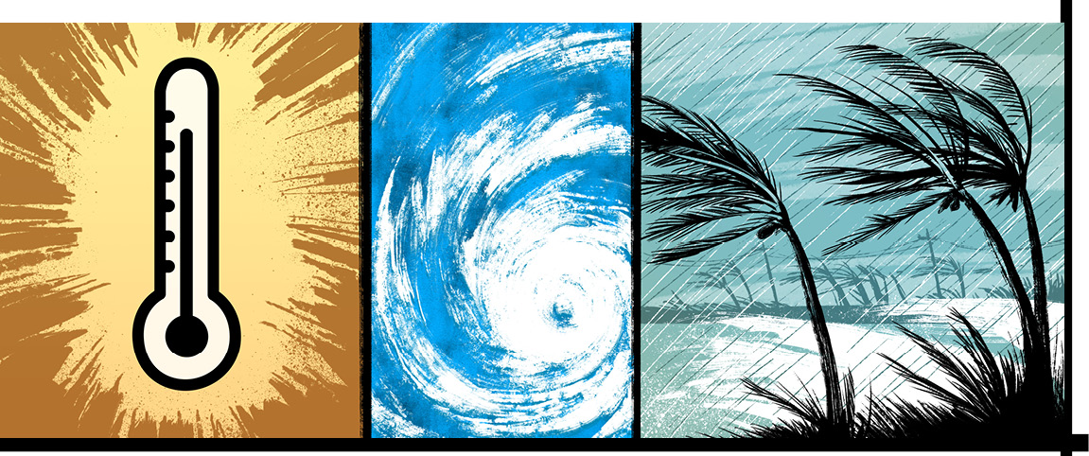

Hurricanes are very strong tropical storms that occur in the Atlantic Ocean. They consist of a large system of powerful winds. These winds circulate around a centre of low **barometric pressure**. They move along the Earth’s surface with a counterclockwise rotation in the northern hemisphere. In the southern hemisphere, their rotation is clockwise.

Hurricanes cause heavy rains, and often **storm surges**. These can bring major destruction, especially when a storm makes landfall in a populated area.

**How Hurricanes Form**

Most storms begin over tropical waters west of Africa. When sea‑surface temperatures are above 26.5 degrees Celsius, water vapour from the ocean rises. This creates an inward movement of air. The air begins to spiral toward the centre of the disturbance. It moves faster and faster the larger the storm gets. Winds in the upper atmosphere can produce a **shear force** to disrupt the system. But if they don't, the storm can increase in height and breadth until it reaches hurricane status. It gains strength as it moves, picking up energy from the warm waters.

**Measuring hurricanes**

Hurricanes are categorized by their wind speeds. The Saffir-Simpson scale rates their severity.

The scale runs from Category 1 through Category 5 in order of increasing intensity. A Category 1 storm has wind speeds of 119 to 153 kilometres per hour. It causes minimal damage. A Category 4 storm is extreme. It can knock down walls, tear off roofs, wreck mobile homes and flood coastal and lowland areas. A Category 5 storm packs winds of 250 kilometres per hour or more. It causes catastrophic damage.

**Naming Hurricanes**

Scientists started naming large storms in 1950. This made communication clearer. It helped people better understand forecasts and warnings.

Each year, a list of names is prepared for the hurricane season. Lists are recycled every six years, but if a storm causes extensive damage, its name is retired.

**Hurricane Season**

In the Atlantic region, hurricane season runs from June 1 to November 30. The most intense storms usually occur between August and October.

Last May, scientists predicted an above-normal hurricane season. About 10 were anticipated and up to seven were expected to emerge as major hurricanes.

By mid-October, nine hurricanes had developed. Two, Hurricane Helene and Hurricane Milton, caused major damage in the Southeastern United States.

**Warming waters**

For years, sea surface temperatures have been warmer in areas where storms often form. Storms pick up more energy when ocean waters are warm, and this can lead to **rapid intensification**. Fast‑growing storms can cause more damage since people have less time to prepare.

One possible factor leading to the warmer water? The ‘Atlantic Multidecadal Oscillation’ (AMO). The AMO is a natural North Atlantic weather cycle. It is currently in a warm phase.

**More to come?**

Global warming may also be a factor. Many scientists say that warm sea waters produce larger storms with more rain, stronger winds, and higher storm surges.

“Human-caused climate change is supercharging them and exacerbating the risk of major damage,” says Dr. Kevin Trenberth, a climate expert.

Hurricane season is not over yet. Scientists are still waiting and watching conditions carefully. The more warnings they can provide, the safer and more prepared people will be.

**Did You Know?**

In the northwest Pacific Ocean, hurricanes are known as typhoons; in the southwest Pacific and Indian Oceans, they’re called cyclones.

**About Global Warming**

‘Greenhouse’ gases exist naturally in the air around Earth. They trap and hold the sun’s heat, warming our planet and making life possible. The problem is that this natural warming system – known as the greenhouse effect – has been thrown out of balance over the last 200 years. More greenhouse gases are gathering in the atmosphere than naturally exist there.

Humans are causing this imbalance By burning fossil fuels to run cars, heat homes, and make products, we are adding greenhouse gases to the atmosphere.

If current trends continue, melting ice will cause ocean levels to keep rising. Low-lying areas around the world will flood. Many animal and plant species will die. Fresh water supplies will decrease, and the world will experience more intense weather more often. Droughts—which are already more frequent—will grow longer and more intense.

In 2024 in Dubai, 197 nations signed the 28th Conference of the Parties under the United Nations Framework Convention on Climate Change (UNFCCC) – COP28 for short. They promised to phase down usage of fossil fuels, triple renewable energy by 2030, and assist countries vulnerable to climate change. They also agreed to strive to limit global warming to 1.50 C above pre-industrial levels.

Even at 1.50 C, there is a risk of a global food crisis and a **permafrost** thaw. Methane released from permafrost alone would be enough to keep the planet warming, thus releasing even more methane. Such a feedback loop would be unstoppable.

Some scientists say that it is already too late to limit global warming to 1.50 C. Others say it’s still possible. Drastic action is needed.

**barometric pressure:** the pressure of the Earth’s atmosphere, as measured by a barometer

**permafrost:** ground that stays permanently frozen, for example in the polar regions

**rapid intensification:** when maximum sustained wind speeds increase by at least 30 knots (56 km per hour) in 24 hours

**shear force:** a difference in wind speed and/or direction over a relatively short distance in the atmosphere

**storm surge:** an unusual, often destructive rise in sea level in a coastal area, caused by low atmospheric pressure and strong winds

**Comprehension Questions**

1. Explain what a **hurricane** is.

2. List three characteristics of a hurricane.

3. What are these types of storms called in other regions of the world?

4. Where do most hurricanes form?

5. Explain how hurricanes form.

6. When is hurricane season in the Atlantic Ocean?

7. How do meteorologists categorize hurricanes? What 'scale' do they use?

8. What is the lowest category on this scale? What is the highest category?

9. Why do meteorologists name hurricanes?

10. How do many scientists believe climate change and storm intensity are connected? Explain.

**Questions For Further Thought**

1. Consider the following quote by Dr. Ilan Kelman at the Institute for Risk and Disaster Reduction and Institute for Global Health at University College London: “***The hurricane is just a storm, it is not the disaster. Climate change did not make people build along vulnerable coastlines so the disaster itself is our choice and is not linked to climate change.***”

a) What is your understanding of Dr. Kelman’s position?

b) For what reasons could you agree with Dr. Kelman? For what reasons could you disagree? Explain.

2. The article discusses how hurricanes are named to make communication with the public clearer and to help people understand forecasts and warnings for particular storms. It also explains that lists of names "are recycled every six years, but if a storm causes extensive damage, its name is retired."

For what reasons might authorities decide to retire the name of a hurricane that causes extensive damage? Explain.

3. Certain regions are more vulnerable to being hit by a hurricane due to their geography and their proximity to the ocean. Why might residents in hurricane-prone regions choose to live in an area that regularly deals with these destructive weather events? Support your response with examples.

**Questions For On Line Exploration**

*Note:* The links below are listed at **www.lesplan.com/links** for easy access.

1. What are hurricanes and how are they formed?  
**https://www.yout-ube.com/watch?v=zP4rgvu4xDE** [1:51]  
**https://www.livescience.com/22177-hurricanes-typhoons-cyclones.html  
https://i.pinimg.com/736x/11/26/80/112680a2a43a812589e5cb279b0816ea.jpg**

What did you learn?

2. Learn about the Saffir-Simpson Hurricane Wind Scale that is used to classify categories of hurricanes based on their wind speed:  
**https://www.nhc.noaa.gov/aboutsshws.php#:~:text=The%20Saffir%2DSimpson%20Hurricane%20Wind,Scale%20estimates%20potential%20property%20damage**

3. How do storm surges work and why can they be so deadly?  
**https://www.yout-ube.com/watch?v=M3nH7euL7xI** [4:49] **https://www.yout-ube.com/watch?v=TJ5C7TsBsao** [4:00]

4. Many scientists suggest that climate change is supercharging hurricanes:  
**https://science.nasa.gov/earth/climate-change/a-force-of-nature-hurricanes-in-a-changing-climate/** [4:26] **https://www.bbc.com/news/world-us-canada-42251921 [1:49]**

Do you agree with them? Why or why not?

**Putting It All Together**

**A. Write the letter that corresponds to the best answer on the line beside each question:**

______ 1. **The Earth's natural warming system is called:** a) climate change b) greenhouse effect  
 c) solar power d) global warming

______ 2. **A __________________ is an unusual, destructive rise in sea level in a coastal area.** a) typhoon b) shear force  
 c) storm surge d) cyclone

______ 3. **What scale is used to classify hurricane intensity?** a) Richter scale c) Beaufort scale  
 b) Vector-Roberts scale d) Saffir-Simpson scale

**B.** Mark the statements **T** (**True**) or F (**False**). If a statement is **True**, write one important fact to support it on the line below. If a statement is **False**, write the words that make it true on the line below.

______ 4. **True** or **False?** The Atlantic hurricane season runs from August to October.

______ 5. **True** or **False?** Hurricane-like storms are called cyclones in the Indian Ocean.

______ 6. **True** or **False?** In the northern hemisphere, hurricane winds rotate clockwise.

**C. Fill in the blanks to complete each sentence.**

7. Scientists started _______________________ large storms in 1950.

8. Most hurricanes begin in the Atlantic Ocean off the continent of _______________________

9. When permafrost thaws _______________________ gas is released into the atmosphere.

**D. Respond to the following question in paragraph form. *(Use a separate sheet of paper if necessary.)***

10. What reasons can you suggest to explain why many scientists believe there is a connection between hurricane size and strength, and global warming?

**Assessment Rubric**

This rubric may be helpful in providing students with formative, strength-based feedback and/or assessing students’ responses holistically. This easy-to-modify activity is included in the doc file which you can download from:   
**www.lesplan.com/subscribers**

|  |  |  |  |  |
| --- | --- | --- | --- | --- |
|  | **Emerging** | **Developing** | **Proficient** | **Extending** |
| **Supports thinking** | Answers or reflections are brief and include obvious facts/details/ evidence. | Answers or reflections are general and supported with some relevant facts/details/evidence. | Answers or reflections are clearly supported with specific, relevant facts/details/evidence. | Answers or reflections are insightful and supported with specific, relevant facts/details/evidence. |
| **Shows understanding** | Responses show a basic understanding of the text, topic, issue or message. | Responses are thoughtful and show a general understanding of the text, topic, issue or message. | Responses are thoughtful and show a complete understanding of the text, topic, issue or message. | Responses are insightful and show a deep understanding the text, topic, issue or message. May synthesize ideas or explain the ‘so what’. |
| **Thinks  critically** | Makes straightforward connections or inferences. Focuses on retelling. | Makes logical connections to self (T:S) and/or background knowledge (T:S). Inferences are logical | Makes meaningful connections to self. Considers ideas between texts (T:T).  Inferences are plausible. | Makes powerful connections that go between texts and/or beyond the text (T:W).  Inferences are plausible and insightful. |