Articles and Questions

Each **free article** of ***The Canadian Reader*** includes:   
  
1) a PDF file

*and*

2) a Word file

These files contain **only** the article and questions. They do **not** contain Answer Keys.

This **Word** file allows students to complete assignments using a computer either at school or at home. Teachers can assign all or parts of the file by email attachment or a school website. The **Word** file also allows teachers to:

• easily modify and format content including changing *fonts* and text sizes

• create a PDF document and use Adobe Reader's 'Read Out Loud Mode'

• save paper and copying costs and help protect the environment

• promote and encourage students’ computer skills

What Else Can You Do With The Word File?

#1) You can easily upload the file to Google Docs and share it with students or other teachers. **See how here:**

<https://support.google.com/drive/answer/2424368?hl=en>

#2) Translate the uploaded document into another language. (see **Tools>Translate document**).Google Docs will create a new copy of the original file but you will need to edit the document to suit your requirements. Google Docs can translate into over 100 languages including Spanish, Mandarin, German, etc. **See how here:**

<https://support.google.com/docs/answer/187189?hl=en&co=GENIE.Platform=Desktop>

A Kick in the Right Direction

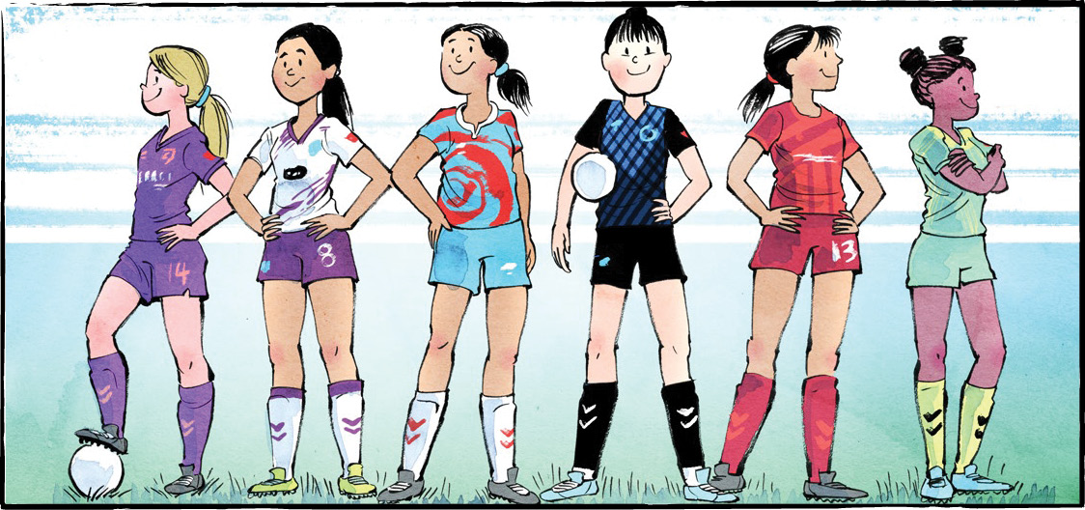

On April 15, 2025, the Calgary Wild FC faced the Vancouver Rise FC at BC Place.

Canadian soccer star Quinn scored the first goal of the match. It was also the only goal of the match. Vancouver won 1-0.

Quinn’s goal made history. It was the first goal ever scored in the Northern Super League (NSL)! The NSL is Canada’s brand-new, professional women’s soccer league.

**A new challenge**

Diane Matheson co-founded the NSL. Ms. Matheson knows a thing or two about soccer. She played 206 games for Canada’s national soccer team. In 2012, she scored the goal that won Olympic bronze for Canada.

In 2021, Ms. Matheson retired. It was time for a new challenge.

Women’s sports have never been more popular. Canada is home to soccer superstars, past and present. In 2020, the Canadian women’s soccer team won Olympic gold! And yet, Canada had no professional soccer league for women.

Ms. Matheson set out to change that.

**A team effort**

Building the league took years of hard work. It took teamwork, too. Luckily, soccer players are good at that.

Many team owners and investors are athletes. They want to support the new league.

Soccer fans will remember Christine Sinclair. Ms. Sinclair captained the Canadian national team before she retired. Now, she is a co-owner of the Vancouver Rise FC.

**Starting with six**

The NSL started with six teams. Vancouver Rise FC and Calgary Wild FC played the first game. The Halifax Tides FC, Montreal Roses FC, AFC Toronto, and Ottawa Rapid FC round out the league.

Ms. Matheson hopes to add more cities in a few years.

There will be 75 matches. Each team will have 25 chances to play. At the end of the season, the top four teams will make the playoffs.

**Canadian talent**

An NSL team can include up to 25 players. All but eight must be Canadian. The idea is to grow Canadian talent.

Casey Stoney coaches the Canadian Women’s National Team. She knows how important a professional league can be. It builds communities and grows the fan base, she says. It lets young players develop without leaving the country. “I believe that’s essential for the future of our game in Canada,” said Ms. Stoney.

The youngest players in the league are Taegan and Keelyn Stewart. The 17-year-old twins will play for Calgary Wild FC. They’re excited to finally play for their own country. “We’re ready to show Canada what we’ve got,” said Taegan.

**A sport for everyone**

The NSL may be a women’s league, but Ms. Matheson knows it will have a wider reach.

The word ‘women’ is not part of the league’s name. That’s no accident. “We didn’t put Canada in the title either,” said Ms. Matheson. She wants people to know that soccer “is for everyone; this league is for everyone.”

FC stands for Football Club. Throughout most of the world, soccer is known as football.

As you see it, what is the importance of the NSL?

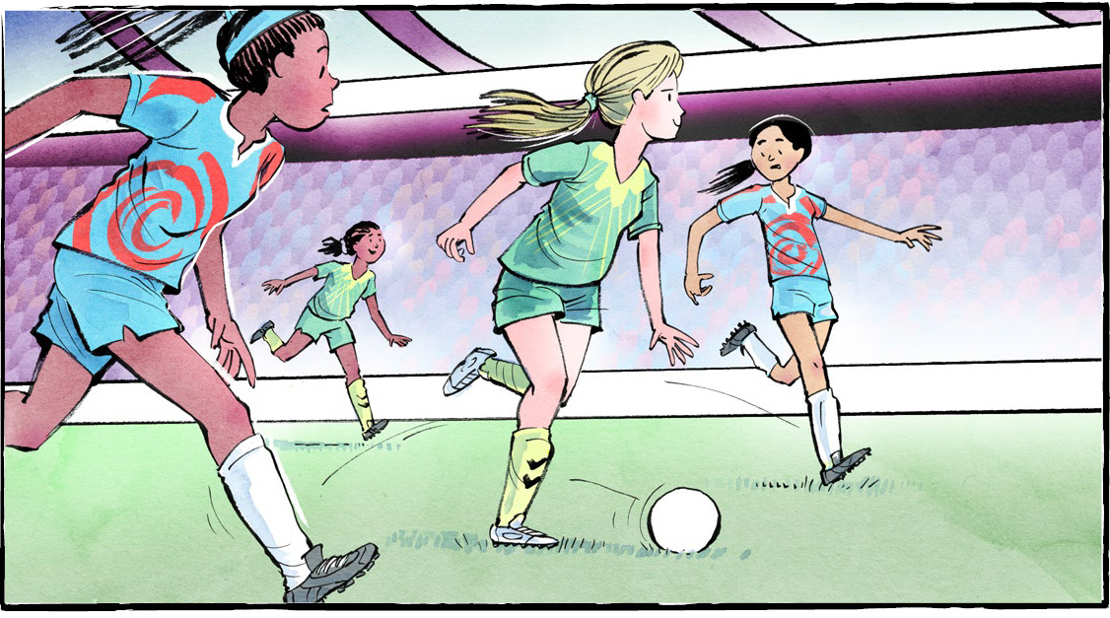

**Comprehension Check**

Mark the statements **T** (True) or **F** (False). If a statement is ***true***, write one fact to support it on the lines below. If a statement is ***false***, write the word or words that make it true on the lines below.

**1.** Quinn scored the first goal in the Northern Super League.

**2.** The Canadian women’s soccer team has never won Olympic gold.

**3.** Christine Sinclair is the co-owner of the Calgary Wild FC.

**4.** There are six teams in the NSL.

**5.** At the end of the season, four teams will make the playoffs.

**6.** Diana Matheson coaches the Canadian Women’s National Team.

**Language Focus**

A **compound word** is formed when two words are joined to form a new word.

Compound words can be:  
**Closed –** *joined together with no spaces* (e.g., spaceship)  
**Hyphenated –** *joined with a hyphen* (e.g., part-time)  
**Open** – *have a space in between but act as one idea* (e.g., ice cream)  
  
Sort the compound words into the correct group:

playground self-esteem runner-up fire truck

living room football toothpaste check-in

swimming pool mailbox long-term high school

Open

Hyphenated

Closed

What other words from the article can you add to each tag?

