Articles and Questions
Each free article of The Canadian Reader includes:
1) a PDF file
and
2) a Word file
These files contain only the article and questions. They do not contain Answer Keys.
This Word file allows students to complete assignments using a computer either at school or at home. Teachers can assign all or parts of the file by email attachment or a school website. The Word file also allows teachers to:
• easily modify and format content including changing fonts and text sizes
• create a PDF document and use Adobe Reader's 'Read Out Loud Mode'
• save paper and copying costs and help protect the environment
• promote and encourage students’ computer skills

What Else Can You Do With The Word File?
#1) You can easily upload the file to Google Docs and share it with students or other teachers. See how here:
https://support.google.com/drive/answer/2424368?hl=en
#2) Translate the uploaded document into another language. (see Tools>Translate document). Google Docs will create a new copy of the original file but you will need to edit the document to suit your requirements. Google Docs can translate into over 100 languages including Spanish, Mandarin, German, etc. See how here:
https://support.google.com/docs/answer/187189?hl=en&co=GENIE.Platform=Desktop

TofiNO Plastic Water Bottles
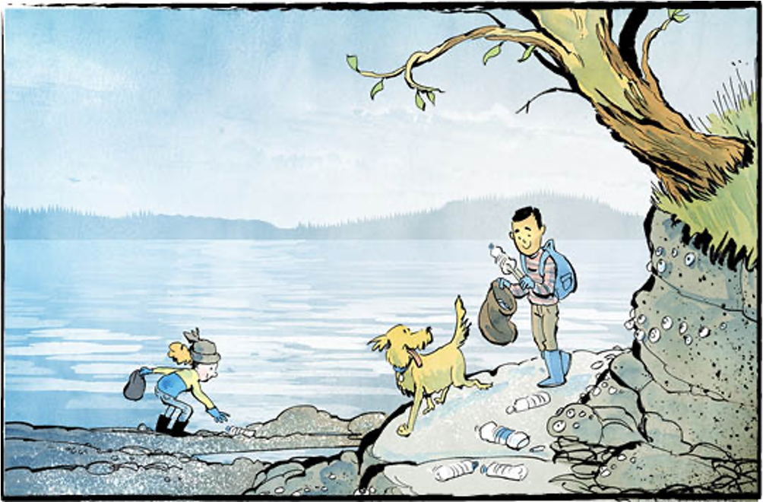

Tofino sits on the west coast of Vancouver Island.
It’s famous for its beautiful beaches. Tourists visit the remote location to hike, surf, and enjoy nature.
On April 22, 2026, Tofino celebrated Earth Day in a big way. It banned single-use plastic water bottles. It is the first Canadian municipality to do so.
There are some exceptions to Tofino’s bottle ban. The ban applies only to bottles that hold one litre of water or less. Water bottles sold in packages or flats are allowed. During emergencies the ban will be lifted.
A plastic problem
In Tofino, shoreline cleanups help keep the beaches beautiful. Some of the most common items found during those cleanups? Single-use plastic bottles.
The problem goes beyond Tofino. Vancouver Island’s west coast is lined with beaches. Some are easy to get to, some are remote. Since 2015, more than 60,000 plastic bottles have been picked up from those beaches.
The bottles also find their way into the ocean.
Plastic bottles are dangerous to wildlife in many ways. For example, animals can eat sharp pieces of plastic. This can injure or even kill them.
Over time, plastic waste breaks down into smaller and smaller pieces. The smallest are called microplastics.
Microplastics are difficult to see. Even so, they can harm or even poison animals. As bigger animals eat smaller ones, microplastics move up the food chain.
Plastics leak toxins into the water, too. These toxins affect all aquatic life.
Sustainable ways
Dan Law is the mayor of Tofino. He says everyone wants to see less plastic waste. “We see it in the landfill, we see it in the beaches,” he said. “We’re acting not to be first, but because we have to.”
Tofino visitors should bring their own reusable water bottles.
Water bottle refill stations will be found in public facilities. Local businesses can also install them. Tofino is providing “free water refills here” decals. That will let people know where to go.
More than words
Tofino has long been a leader when it comes to the environment. It has already banned other single-use plastic items. These include bags, straws, and utensils. Styrofoam containers are also banned.
“Protecting the health of our coastlines requires more than just words,” says Mayor Law. “It requires a collective shift in how we live and do business.”
What do you think? Should other places follow in Tofino’s footsteps?

Plastic is made from fossil fuels like oil and natural gas.
These are non-renewable resources.

Do you agree with the ban? Why or why not?

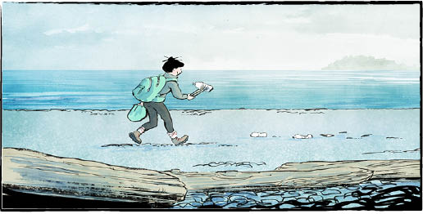
Did you know?
Over 5.3 million bottles of water are sold in Canada every day!

Comprehension Check
Write the letter of the best answer in the space beside each question.
1. What is Tofino famous for?
a) Champion surfers. b) Fossil fuels.
c) Beautiful beaches. d) Dangerous wildlife.
2. Which water bottles are still allowed under Tofino’s ban?
a) One-litre bottles.
b) No water bottles are allowed at all.
c) Bottles sold in packages.
d) Bottles sold near the beach.
3. How many plastic bottles have been picked up from Vancouver Island’s west coast since 2015?
a) More than 60,000. b) Millions.
c) Less than 50,000. d) Around 2000.
4. What are microplastics?
a) A special type of beach rock.
b) Small pieces of broken-down plastic.
c) Plastic pieces used for recycling.
d) Single-use water bottles.
5. What can visitors to Tofino do instead of buying plastic water bottles?
a) Buy glass water bottles. b) Drink only juice.
c) Avoid drinking water. d) Bring their own reusable bottles.

Language Focus
Match each word from the list below with its correct definition:
ban emergency injure landfill
microplastics municipality remote reusable
sustainable tourists toxins wildlife

1. far away and hard to get to
2. a serious situation that needs quick action
3. tiny pieces of broken-down plastic
4. animals living in nature
5. to hurt or harm
6. harmful chemicals or poisons
7. a place where garbage is buried
8. something that can be used over again
9. able to continue without harming nature
10. a city, town, or area with its own local government
11. to officially stop or not allow something
12. people who travel to visit a place for fun

