Articles and Questions
Each issue of The Canadian Reader includes:
1) a PDF file (the complete document) and
2) a Word file that contains only the articles and questions. This file does not contain an Answer Key.
This Word file allows students to complete assignments using a computer either at school or at home. Teachers can assign all or parts of the file by email attachment or a school website. The Word file also allows teachers to:
• easily modify and format content including changing fonts and text sizes
• create a PDF document and use Adobe Reader's 'Read Out Loud Mode'
• save paper and copying costs and help protect the environment
• promote and encourage students’ computer skills

Access Data
There are two main ways to access the data in this Word file:
1) Open the Word file and select the data you wish to Copy. Then Paste the data it into any word processing or email program. Use Select All to copy the entire document.
2) Most word processing programs will open Word files. You can use LibreOffice or Open Office (or another similar free program) to open and save .docx Word files.
See: www.libreoffice.org/discover/libreoffice/ www.openoffice.org

What Else Can You Do With The Word File?
#1) You can easily upload the file to Google Drive and share it with students or other teachers. See how here:
https://support.google.com/drive/answer/2424368?hl=en
#2) Translate the uploaded document into another language. (see Tools>Translate document). Google Docs will create a new copy of the original file but you will need to edit the document to suit your requirements. Google Docs can translate into over 100 languages including Spanish, Mandarin, German, etc. See how here:
https://support.google.com/docs/answer/187189?hl=en&co=GENIE.Platform=Desktop

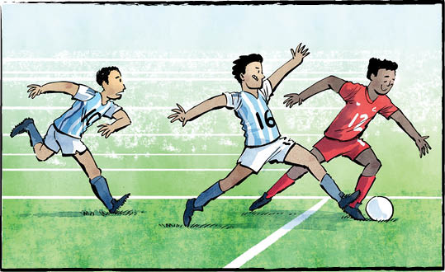
FIFA World Cup Comes to Canada!

Three host countries: Canada, the United States, and Mexico. Forty-eight teams. One hundred and four soccer matches. The biggest FIFA World Cup ever “kicks off” in June!
A growing tournament
The first World Cup was held in 1930. It included only thirteen teams. At the time, soccer wasn’t part of the Olympics. The World Cup was created so countries could play against each other.
By 1998, the World Cup had grown to 32 teams. In 2022, the number was the same. This year’s tournament is the first to include 48 teams.
For four nations, this will be their first World Cup tournament! Cape Verde, Curacao, Jordan, and Uzbekistan are competing for the first time.
How the World Cup works
Games will take place from June 11 to July 19.
The teams have been divided into twelve groups of four. Canada is in group B. So are Bosnia and Herzegovina (one team), Qatar, and Switzerland.
The tournament starts with a group stage. Each team plays all the others in its group. The top two teams from each group advance. So do the eight best third-place teams.
That means 32 teams enter the playoff stage. In this stage, the winner of each match moves on. The loser is eliminated.
There is one exception. The teams that lose in the semifinals play each other for third place.
Canada plays host
Canada has never hosted a World Cup before! Toronto and Vancouver will both host matches during the group stage. So will many cities in the United States and Mexico.
Each playoff round needs fewer host cities. Toronto and Vancouver will host matches in round one. In round two, Vancouver will host, but not Toronto.
The final match will take place in East Rutherford, New Jersey.
A sport that unites
FIFA takes pride in football’s ability to unite people. The sport reaches across countries and cultures. Canada is getting ready to celebrate that spirit.
Football is “a universal language,” said Canada Soccer President Peter Augruso. “Here in Canada it’s spoken every day in our schools, parks, community centres, and stadiums, from coast to coast to coast.”
Get ready to cheer for your favourite team!

FIFA stands for Fédération Internationale de Football Association. In English? International Federation of Association Football.

Will you watch any World Cup matches? Why or why not?

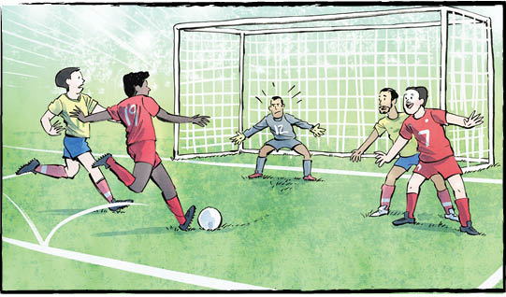
Did you know?
The FIFA Women’s World Cup also takes place every four years.
The next tournament is in 2027, in Brazil.
Comprehension Check
Mark the statements T (True) or F (False). If a statement is true, write one fact to support it on the lines below. If a statement is false, write the word or words that make it true on the lines below.
1. The World Cup takes place every four years.

2. The first ever World Cup included 32 teams.

3. Curacao and Uzbekistan are competing for the first time.

4. Group B includes Canada, Qatar, Switzerland, and Jordan.

5. This is Canada’s first time hosting a World Cup.

6. Matches in Canada will be played in Toronto, Vancouver, and Montreal.

Language Focus

Proper nouns name specific people, places and things. They begin with a capital letter.
Can you find the proper nouns in the article? Write them in the appropriate circles below.

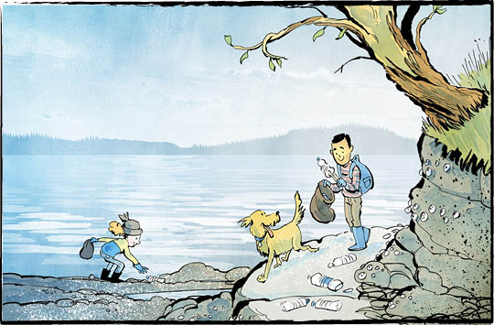
TofiNO Plastic Water Bottles

Tofino sits on the west coast of Vancouver Island.
It’s famous for its beautiful beaches. Tourists visit the remote location to hike, surf, and enjoy nature.
On April 22, 2026, Tofino celebrated Earth Day in a big way. It banned single-use plastic water bottles. It is the first Canadian municipality to do so.
There are some exceptions to Tofino’s bottle ban. The ban applies only to bottles that hold one litre of water or less. Water bottles sold in packages or flats are allowed. During emergencies the ban will be lifted.
A plastic problem
In Tofino, shoreline cleanups help keep the beaches beautiful. Some of the most common items found during those cleanups? Single-use plastic bottles.
The problem goes beyond Tofino. Vancouver Island’s west coast is lined with beaches. Some are easy to get to, some are remote. Since 2015, more than 60,000 plastic bottles have been picked up from those beaches.
The bottles also find their way into the ocean.
Plastic bottles are dangerous to wildlife in many ways. For example, animals can eat sharp pieces of plastic. This can injure or even kill them.
Over time, plastic waste breaks down into smaller and smaller pieces. The smallest are called microplastics.
Microplastics are difficult to see. Even so, they can harm or even poison animals. As bigger animals eat smaller ones, microplastics move up the food chain.
Plastics leak toxins into the water, too. These toxins affect all aquatic life.
Sustainable ways
Dan Law is the mayor of Tofino. He says everyone wants to see less plastic waste. “We see it in the landfill, we see it in the beaches,” he said. “We’re acting not to be first, but because we have to.”
Tofino visitors should bring their own reusable water bottles.
Water bottle refill stations will be found in public facilities. Local businesses can also install them. Tofino is providing “free water refills here” decals. That will let people know where to go.
More than words
Tofino has long been a leader when it comes to the environment. It has already banned other single-use plastic items. These include bags, straws, and utensils. Styrofoam containers are also banned.
“Protecting the health of our coastlines requires more than just words,” says Mayor Law. “It requires a collective shift in how we live and do business.”
What do you think? Should other places follow in Tofino’s footsteps?

Plastic is made from fossil fuels like oil and natural gas. These are non-renewable resources.

Do you agree with the ban? Why or why not?

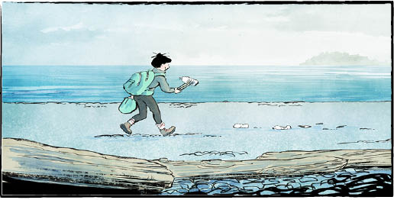
Did you know?
Over 5.3 million bottles of water are sold in Canada every day!
Comprehension Check
Write the letter of the best answer in the space beside each question.
1. What is Tofino famous for?
a) Champion surfers. b) Fossil fuels.
c) Beautiful beaches. d) Dangerous wildlife.
2. Which water bottles are still allowed under Tofino’s ban?
a) One-litre bottles.
b) No water bottles are allowed at all.
c) Bottles sold in packages.
d) Bottles sold near the beach.
3. How many plastic bottles have been picked up from Vancouver Island’s west coast since 2015?
a) More than 60,000. b) Millions.
c) Less than 50,000. d) Around 2000.
4. What are microplastics?
a) A special type of beach rock.
b) Small pieces of broken-down plastic.
c) Plastic pieces used for recycling.
d) Single-use water bottles.
5. What can visitors to Tofino do instead of buying plastic water bottles?
a) Buy glass water bottles. b) Drink only juice.
c) Avoid drinking water. d) Bring their own reusable bottles.

Language Focus
Match each word from the list below with its correct definition:
ban emergency injure landfill
microplastics municipality remote reusable
sustainable tourists toxins wildlife

1. far away and hard to get to
2. a serious situation that needs quick action
3. tiny pieces of broken-down plastic
4. animals living in nature
5. to hurt or harm
6. harmful chemicals or poisons
7. a place where garbage is buried
8. something that can be used over again
9. able to continue without harming nature
10. a city, town, or area with its own local government
11. to officially stop or not allow something
12. people who travel to visit a place for fun

Meet Canada’s Next Governor General
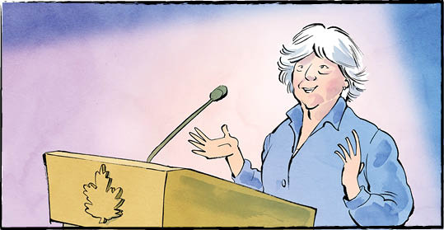

On May 5, 2026, Louise Arbour was named as Canada’s next governor general (GG). She will be sworn in on June 8, 2026.
Ms. Arbour will be Canada’s 31st governor general. She replaces Mary Simon, who has held the title since July 26, 2021.
“As Mary Simon has, Louise Arbour will represent the best of Canada to Canadians and to the world,” said Prime Minister Carney.
What is a governor general?
Canada is a monarchy. That means we have a king (or queen) as our head of state.
King Charles III lives in England. So the government chooses a governor general to represent him in Canada.
The GG doesn’t actually run the country, though. We elect a government to do that.
Much of what a governor general does is ceremonial. She attends events. She hands out medals and honours. She hosts state dinners. She travels the country to meet Canadians. She is the Commander-in-Chief of the Armed Forces (although she doesn’t really command them). In Parliament, the GG approves all bills before they become law.
Upholding the law
Some of the GG’s hardest duties take place behind the scenes.
She makes sure each new government is formed correctly. She makes sure it runs as it should. When the time comes, she makes sure it is dissolved correctly. Everything must follow Canada’s constitution and laws.
Ms. Arbour is well suited to this job. She has spent her life upholding the law.
Heart of gold, spine of steel
Our new governor general was born in Montreal. She speaks fluent French and English.
She grew up to become a lawyer. Her specialty? Criminal law.
In 1987, she became a judge. Even outside the court, she was hard at work. She fought against the abuse of women in a prison in Kingston, Ontario. A colleague from that time says she has “a heart of gold and a spine of steel.”
Ms. Arbour went on to work in international law. She prosecuted war criminals. In 1999, she returned to Canada as a Supreme Court judge.
Most people would retire after a job like that. Not Ms. Arbour. After stepping down in 2004, she worked with the United Nations. Her focus was supporting human rights.
Changing lives
In 2007, Ms. Arbour was awarded the Order of Canada. That’s the highest honour a civilian can receive. She has also received 42 honorary doctorate degrees.
Ms. Arbour’s accomplishments are remarkable. Prime Minister Carney feels there’s something even more important, though: “The lives she has changed through her service.”

Ms. Arbour is 79 years old. She will be the oldest person ever to become GG.

What questions would you like to ask Ms. Arbour?

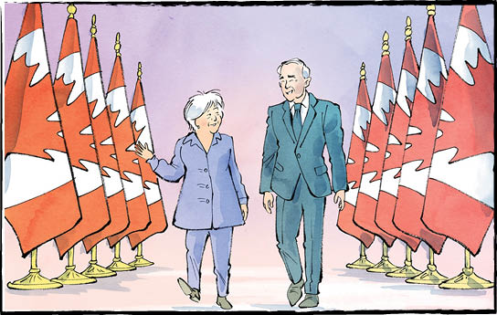

Comprehension Check
Answer the questions below in complete sentences:

1. Who will Louise Arbour replace as governor general?

2. Who does the governor general represent in Canada?

3. List three responsibilities of the governor general.

4. What job did Ms. Arbour have when she returned to Canada in 1999?

5. What honour was Ms. Arbour awarded in 2007?

Language Focus

An action verb describes what the subject does.
Example: The boy and his friends play hockey at recess.
A linking verb links the subject to words describing the subject.
Example: The television is broken
Common linking verbs include is, am, are, was, were.

Circle the verbs, then indicate the type of verb: (A) action or (L) linking.
1. : Louise Arbour was born in Montreal.
2. : She speaks fluent French and English.
3. : In 1999, she returned to Canada.
4. : Louise Arbour was named as Canada’s next governor general.
5. : Ms. Arbour worked with the United Nations.

What other examples of action or linking verbs can you find in the article

