Articles and Questions
Each issue of The Canadian Reader includes:
1) a PDF file (the complete document) and
2) a Word file that contains only the articles and questions. This file does not contain an Answer Key.
This Word file allows students to complete assignments using a computer either at school or at home. Teachers can assign all or parts of the file by email attachment or a school website. The Word file also allows teachers to:
• easily modify and format content including changing fonts and text sizes
• create a PDF document and use Adobe Reader's 'Read Out Loud Mode'
• save paper and copying costs and help protect the environment
• promote and encourage students’ computer skills

Access Data
There are two main ways to access the data in this Word file:
1) Open the Word file and select the data you wish to Copy. Then Paste the data it into any word processing or email program. Use Select All to copy the entire document.
2) Most word processing programs will open Word files. You can use LibreOffice or Open Office (or another similar free program) to open and save .docx Word files.
See: www.libreoffice.org/discover/libreoffice/ www.openoffice.org

What Else Can You Do With The Word File?
#1) You can easily upload the file to Google Drive and share it with students or other teachers. See how here:
https://support.google.com/drive/answer/2424368?hl=en
#2) Translate the uploaded document into another language. (see Tools>Translate document). Google Docs will create a new copy of the original file but you will need to edit the document to suit your requirements. Google Docs can translate into over 100 languages including Spanish, Mandarin, German, etc. See how here:
https://support.google.com/docs/answer/187189?hl=en&co=GENIE.Platform=Desktop

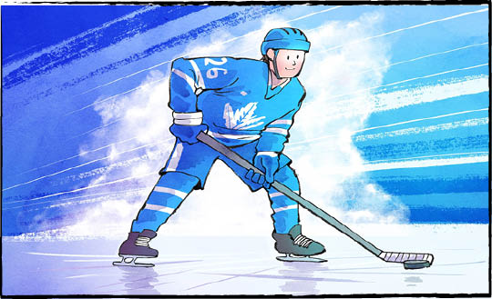
Meet Gavin McKenna

On June 26, a dream came true for hockey player Gavin McKenna. The 18-year-old left winger was drafted to the National Hockey League (NHL). He was chosen first overall.
The lucky team? The Toronto Maple Leafs. Mr. McKenna signed a three-year, entry-level contract. He has already started training with the team.
Northern pride
Mr. McKenna comes from Whitehorse, Yukon. He is a member of the Tr'ondëk Hwëch'in First Nation.
On draft night in Buffalo, New York, he showed how much his ancestry means to him. The jacket lining of his suit was printed with photos of his family and friends. He also wore two beaded wolf pins, made by his sister. They represent the family’s clan.
"My grandfather went to a Residential School,” Mr. McKenna later said. “Seeing how far he's come has taught me to be resilient and not take anything for granted."
Breaking barriers
This is just the second time an Indigenous player from Canada has been the top draft pick. In 1977, the Detroit Red Wings drafted Dale McCourt. Mr. McCourt is a member of the Kitigan Zibi Anishinabeg First Nation in Quebec.
Rebecca Chartrand is Canada’s Minister of Northern and Arctic Affairs. She watched as Mr. McKenna’s name was called. She called it an “electrifying moment.”
“He shattered barriers and lifted his Tr'ondëk Hwëch'in Nation onto the world stage,” Ms. Chartrand wrote. “The North is roaring with pride and so are Indigenous Peoples across Canada.”
Setting goals
The hockey world has had its eyes on Mr. McKenna for years.
From the age of fourteen, he played in the Western Hockey League (WHL). Mr. McKenna spent three years with the Medicine Hat Tigers. During the 2024-25 season, he led the entire Canadian Hockey League (CHL) with 129 points. (The WHL is part of the CHL.)
Last year, he played for Pennsylvania State University. In 35 games, he scored 15 goals and 36 assists.
Sportswriter Justin Bourne calls him a “creator.” Mr. McKenna sees what is happening on the ice. He creates opportunities for the team to score.

A good sport
It’s already clear that Mr. McKenna is a team player. When he started training with the Leafs, he chose his usual jersey number, 72. Then the Leafs signed experienced goaltender Sergei Bobrovsky. Mr. Bobrovsky has worn number 72 for his whole career.
What did Mr. McKenna do? Gave him the jersey with 72 on it, of course.
No matter his number, Mr. McKenna is excited to be in Toronto. In fact, the day after the draft, he went to his first Blue Jays game. He threw the first pitch! It went high. Luckily, he’s better with a hockey puck.
"I've got a lot of young fans watching me,” Mr. McKenna said. “So I obviously want to represent the Indigenous community well, be a good role model for young kids, and make them proud."

What is a role model? As you see it, why is Gavin McKenna a good role model?

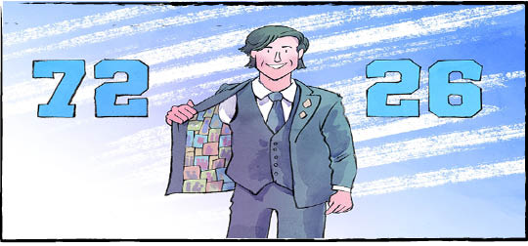

Comprehension Check
Write the letter of the best answer in the space beside each question.

1. Which NHL team drafted Gavin McKenna?
a) Ottawa Senators. b) Detroit Red Wings.
c) Toronto Maple Leafs. d) Edmonton Oilers.
2. What was inside Gavin McKenna’s suit jacket?
a) A ticket to a Blue Jays game. b) A contract.
c) Photos of his family and friends. d) Two beaded wolf pins.
3. Who is Dale McCourt?
a) Canada’s Minister of Northern and Arctic Affairs.
b) The first Canadian Indigenous player drafted to the NHL.
c) Pennsylvania State University’s hockey coach.
d) A member of Tr'ondëk Hwëch'in First Nation.
4. What jersey number did Gavin McKenna give up to Sergei Bobrovsky?
a) 36. b) 15.
c) 26. d) 72.
5. What did Mr. McKenna do the day after the draft?
a) He went to his first Blue Jays game.
b) He started training with the Leafs.
c) He called the Medicine Hat Tigers’ coach.
d) He returned to Whitehorse, Yukon.

Language Focus
Nouns name people, places, or things. They can be common or proper.
Common nouns name general things: lake, teacher, city
Proper nouns always begin with a capital letter. They name a specific person, place, or thing: Lake Ontario, Mrs. Bain, Saskatoon

Directions: Complete the table by writing the following nouns in the appropriate column:
Gavin McKenna player number Toronto
barriers season games Quebec
hockey puck community friends Canada
Rebecca New York National Hockey League
Common Noun | Proper Noun
What other common and proper nouns can you find in the article?
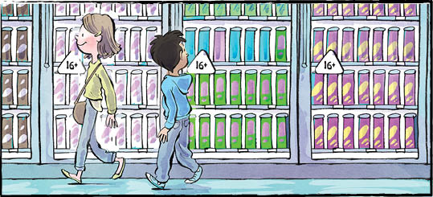
Quebec Cans Energy Drinks

Soon, most teens won’t be able to buy energy drinks in Quebec. In June, the Quebec government passed Bill 9. The new law bans the sale of drinks like Red Bull and Monster to youth aged 15 and under.
The law takes effect in December 2026. It is the first of its kind in North America.
Strict new rules
What are energy drinks? They are beverages that contain at least 150 milligrams of caffeine per litre. They also contain other chemicals or natural substances. Some examples are vitamins, minerals, and taurine.
Under the new law, people are banned from selling or giving an energy drink to anyone under 16. Stores must ask for ID to confirm age.
A person under 16 who breaks the law could face a $100 fine. Adults can be charged between $500 and $1500. Businesses could pay up to $62,500.
Selling energy drinks online is against the law, too. So is selling them in vending machines.

There’s a limit
Why is Quebec taking these steps? Because too much caffeine is harmful for youth.
The daily maximum is around 100 milligrams for teens. It’s much less for kids. Consuming more than the limit can be dangerous.
Caffeine can make sleeping difficult. It can disrupt your heart and heartbeat. It can cause problems with digestion. It can raise blood pressure. It can cause headaches. It can make you anxious. It can make focusing difficult.
When mixed with some medications, high levels of caffeine can be life-threatening.
“Even with just one drink, you’re often exceeding the daily caffeine maximum for a young person,” said Dr. Nicholas Chadi. He works at a children's hospital in Montreal, Quebec.
The problem with energy drinks
Many foods contain caffeine. So why does the new law target energy drinks? Because they make it easy for youth to consume caffeine in large amounts.
The drinks are high in sugar. They are sweet and tasty. Many youth don’t stop at one can.
Energy drinks can also contain other ingredients that add to caffeine’s impact. Ginseng is one example.
When energy drinks are added to caffeine from other sources, it’s even easier for youth to get too much.
“If a young person is going to have an energy drink but also an iced coffee and a chocolate bar and a soda, that really increases the risks,” said Dr. Chadi.

Safety first
Still, some people are against the ban. So is the beverage industry. Critics say that educating youth about the effects of caffeine is a better solution.
But many parents, teachers, and school groups support the new law. So do many doctors and pharmacists. They agree with the government that energy drinks are not worth the risk for youth.
“We believe it is better to act preventively when the health of young people is at stake,” stated Quebec Health Minister Sonia Bélanger.

Taurine is found naturally in some foods. A lab-made version is added to energy drinks to help calm the jittery effects of caffeine.

Do you agree with the energy drinks ban? Why or why not?

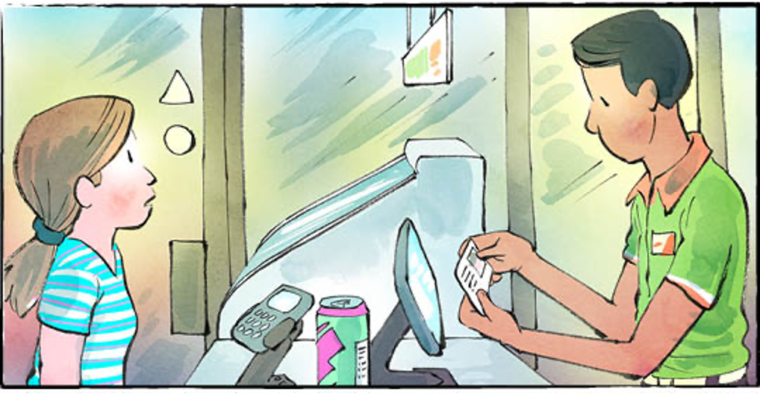

Comprehension Check
Answer the questions below in complete sentences:

1. What does Bill 9 ban in Quebec?

2. What must stores ask for before selling an energy drink?

3. List two other places where it is against the law to sell energy drinks.

4. What is the daily maximum of caffeine for teens?

5. Name two health problems that too much caffeine can cause.

6. Who is against the ban?

Language Focus
A definite article (the) is used when you talk about something specific.
(For example: The dog is sleeping on the couch.)
Indefinite articles (a, an) are used when you talk about something not specific.
(For example: I saw a cat in the garden. She ate an apple.)
Use "a" before words that start with a consonant sound. Use "an" before words that start with a vowel sound.

Write the article the, a, or an in the blanks below:
1. ________ energy drink ban takes effect in December 2026.
2. Dr. Chadi works at works at ________ children's hospital.
3. Youth should not order ________ energy drink, ________ iced coffee and ________ soda
all at once.
4. Selling energy drinks online is against ________ law.
5. Ana knows all ________ letters of ________ alphabet.

Now write three sentences of your own using the, a, and an.
1.
2.
3.
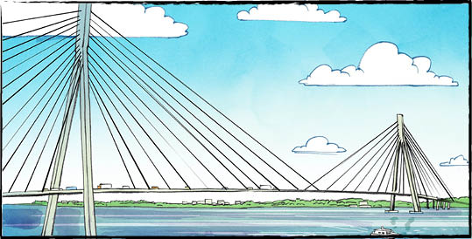
Howe to Bridge Two Countries

The Gordie Howe International Bridge opened on July 27, 2026. The bridge reaches across the Detroit River. It connects Windsor, Ontario with Detroit, Michigan.
Why a new bridge?
There are already bridges between Michigan and Ontario. There’s even one between Detroit and Windsor! That one, the Ambassador Bridge, is privately owned. There is a privately owned tunnel between the two cities, too. So why was another bridge built?
More than 25 percent of the trade between Canada and the United States moves through the Detroit-Windsor border. Trucks carrying goods worth hundreds of millions of dollars cross the river here every single day.
The new bridge will get them across the border faster. That means less time waiting in line. It also means less wasted gas. Have you ever heard that time is money? In this case, it’s true.
Six lanes and more
Construction on the Gordie Howe bridge began in 2018.
The bridge has six lanes. Three carry traffic to Canada. Three carry traffic to Michigan. There is a multi-use laneway, too. The laneway is for pedestrians and bicycles. It opened in early August.
The bridge is “cable-stayed.” Straight, steel cables connect the bridge to support towers. The cables transfer the weight of the bridge to the towers. The towers transfer it to the foundations.
The Gordie Howe bridge is the longest cable-stayed bridge in North America. Its main span is 853 metres long. The whole bridge is about 2.5 kilometres long.

Joint owners
Canada and Michigan own the bridge together. Canada paid to build the bridge. The price? Over four billion dollars.
Canada will be paid back over time, as the bridge makes money. One way this will happen is through tolls. People will pay to use the bridge.
Rick Snyder was governor of Michigan when the original agreement was signed. He is grateful to Canada for covering the construction costs. “That was an incredible goodwill gesture,” he said.

Separate celebrations
Canada celebrated the bridge opening on July 24.
The original plan was a joint celebration. Unfortunately, in late July, relations between the countries were not good. Canada chose to celebrate alone.
The hope is that, long-term, the bridge will help bring the two countries together.
Drew Dilkens is the mayor of Windsor. “Gordie Howe was known for kindness, respect and his tenacity to win,” he said. “We hope everyone would aspire to demonstrate the ideals he represents.

Tolls are money paid to drive on a highway, cross a bridge, or use a tunnel.

As you see it, why was it important to build a new bridge in this location?

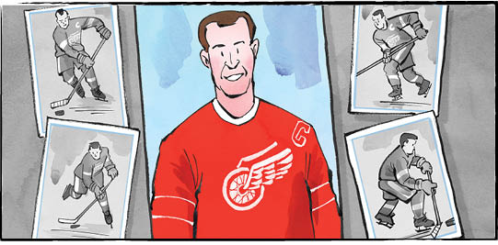
Gordie Howe was a famous Canadian hockey player. He played for the Detroit Red Wings for 25 seasons. “Mr. Hockey” lived from 1928 to 2016. He is considered one of the greatest players of all time.
Comprehension Check
Mark the statements T (True) or F (False). If a statement is true, write one fact to support it on the lines below. If a statement is false, write the word or words that make it true on the lines below.

_________ 1. The Gordie Howe International Bridge reaches across the Detroit River.

_________ 2. The new bridge has four lanes for traffic.

_________ 3. People can drive, walk, or ride their bikes across the bridge.

_________ 4. Construction on the Gordie Howe International Bridge began in 2022.

_________ 5. The Gordie Howe Bridge is the longest cable-stayed bridge in North America.

_________ 6. The bridge officially opened on July 27.

Language Focus

Connect the words with their definition.

Now use three of these words in your own sentences.

1.

2.

3.

