Articles and Questions

Each issue of ***The Canadian Reader*** includes:   
  
1) a PDF file (the complete document) **and**

2) a Word file that contains **only** the articles and questions. This file does **not** contain an Answer Key.

This **Word** file allows students to complete assignments using a computer either at school or at home. Teachers can assign all or parts of the file by email attachment or a school website. The **Word** file also allows teachers to:

• easily modify and format content including changing fonts and text sizes

• create a PDF document and use Adobe Reader's 'Read Out Loud Mode'

• save paper and copying costs and help protect the environment

• promote and encourage students’ computer skills

Access Data

There are two main ways to access the data in this Word file:

1) Open the **Word** file and select the data you wish to **Copy.** Then **Paste** the data it into any word processing or email program. Use **Select All** to copy the entire document.

2) Most word processing programs will open **Word** files. You can use **LibreOffice** or **Open Office** (or another similar free program) to open and save **.docx** Word files.

See: [www.libreoffice.org/discover/libreoffice/](http://www.libreoffice.org/discover/libreoffice/) [www.openoffice.org](http://www.openoffice.org)

What Else Can You Do With The Word File?

#1) You can easily upload the file to Google Drive and share it with students or other teachers. **See how here:**

<https://support.google.com/drive/answer/2424368?hl=en>

#2) Translate the uploaded document into another language. (see **Tools>Translate document**).Google Docs will create a new copy of the original file but you will need to edit the document to suit your requirements. Google Docs can translate into over 100 languages including Spanish, Mandarin, German, etc. **See how here:**

<https://support.google.com/docs/answer/187189?hl=en&co=GENIE.Platform=Desktop>

A Kick in the Right Direction

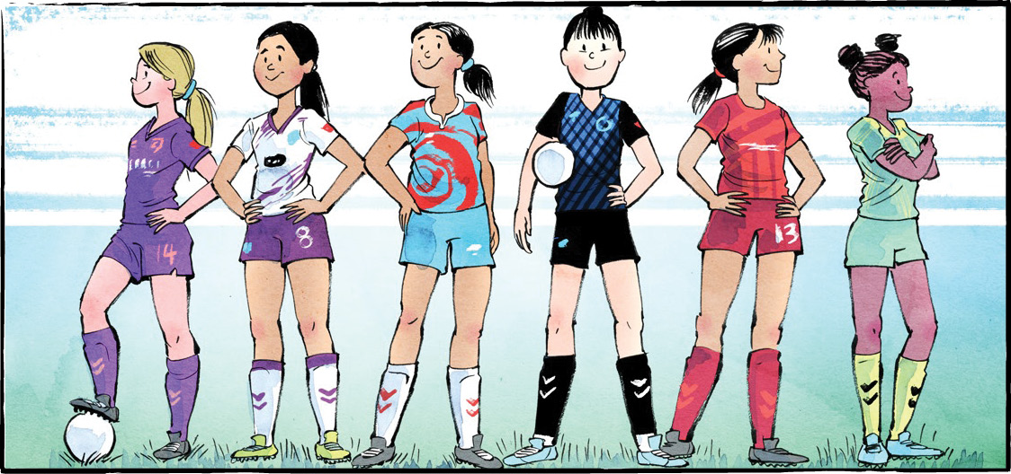

On April 15, 2025, the Calgary Wild FC faced the Vancouver Rise FC at BC Place.

Canadian soccer star Quinn scored the first goal of the match. It was also the only goal of the match. Vancouver won 1-0.

Quinn’s goal made history. It was the first goal ever scored in the Northern Super League (NSL)! The NSL is Canada’s brand-new, professional women’s soccer league.

**A new challenge**

Diane Matheson co-founded the NSL. Ms. Matheson knows a thing or two about soccer. She played 206 games for Canada’s national soccer team. In 2012, she scored the goal that won Olympic bronze for Canada.

In 2021, Ms. Matheson retired. It was time for a new challenge.

Women’s sports have never been more popular. Canada is home to soccer superstars, past and present. In 2020, the Canadian women’s soccer team won Olympic gold! And yet, Canada had no professional soccer league for women.

Ms. Matheson set out to change that.

**A team effort**

Building the league took years of hard work. It took teamwork, too. Luckily, soccer players are good at that.

Many team owners and investors are athletes. They want to support the new league.

Soccer fans will remember Christine Sinclair. Ms. Sinclair captained the Canadian national team before she retired. Now, she is a co-owner of the Vancouver Rise FC.

**Starting with six**

The NSL started with six teams. Vancouver Rise FC and Calgary Wild FC played the first game. The Halifax Tides FC, Montreal Roses FC, AFC Toronto, and Ottawa Rapid FC round out the league.

Ms. Matheson hopes to add more cities in a few years.

There will be 75 matches. Each team will have 25 chances to play. At the end of the season, the top four teams will make the playoffs.

**Canadian talent**

An NSL team can include up to 25 players. All but eight must be Canadian. The idea is to grow Canadian talent.

Casey Stoney coaches the Canadian Women’s National Team. She knows how important a professional league can be. It builds communities and grows the fan base, she says. It lets young players develop without leaving the country. “I believe that’s essential for the future of our game in Canada,” said Ms. Stoney.

The youngest players in the league are Taegan and Keelyn Stewart. The 17-year-old twins will play for Calgary Wild FC. They’re excited to finally play for their own country. “We’re ready to show Canada what we’ve got,” said Taegan.

**A sport for everyone**

The NSL may be a women’s league, but Ms. Matheson knows it will have a wider reach.

The word ‘women’ is not part of the league’s name. That’s no accident. “We didn’t put Canada in the title either,” said Ms. Matheson. She wants people to know that soccer “is for everyone; this league is for everyone.”

FC stands for Football Club. Throughout most of the world, soccer is known as football.

As you see it, what is the importance of the NSL?

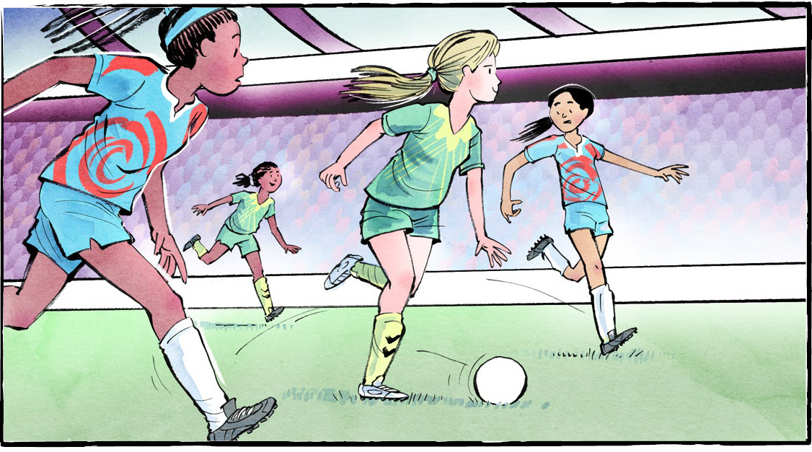

**Comprehension Check**

Mark the statements **T** (True) or **F** (False). If a statement is ***true***, write one fact to support it on the lines below. If a statement is ***false***, write the word or words that make it true on the lines below.

**1.** Quinn scored the first goal in the Northern Super League.

**2.** The Canadian women’s soccer team has never won Olympic gold.

**3.** Christine Sinclair is the co-owner of the Calgary Wild FC.

**4.** There are six teams in the NSL.

**5.** At the end of the season, four teams will make the playoffs.

**6.** Diana Matheson coaches the Canadian Women’s National Team.

**Language Focus**

A **compound word** is formed when two words are joined to form a new word.

Compound words can be:  
**Closed –** *joined together with no spaces* (e.g., spaceship)  
**Hyphenated –** *joined with a hyphen* (e.g., part-time)  
**Open** – *have a space in between but act as one idea* (e.g., ice cream)

Sort the compound words into the correct group:

playground self-esteem runner-up fire truck

living room football toothpaste check-in

swimming pool mailbox long-term high school

Open

Hyphenated

Closed

What other words from the article can you add to each tag?

Election Upheaval

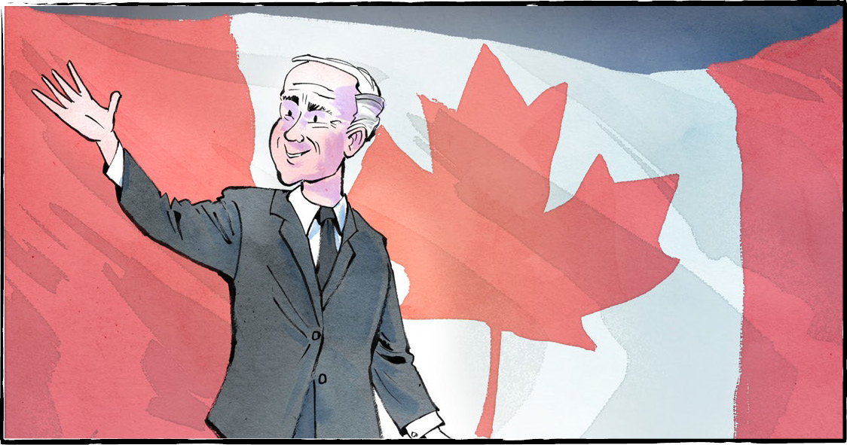

On April 28, Canada held a federal election. The Liberal Party, led by Prime Minister Mark Carney, won.

**Voter turnout**

Canadians had strong feelings about this election. More than 19.5 million Canadians voted. That’s over 68 percent of eligible voters.

It’s not a record high. That was set in 1958, when 79.4 percent of voters cast ballots. However, this is the highest turnout since 1993, when 69.6 percent voted.

**Remarkable results**

This election held some surprises.

For starters, there was more turnover than usual. In 2021, only 7 percent of seats changed hands. This time, 57 out of 343 seats changed hands. That’s 17 percent!

Another shock was that some party leaders lost their seats. Conservative leader Pierre Poilievre was not elected in his home riding. Neither was New Democratic Party (NDP) leader Jagmeet Singh. One of the Green Party co-leaders also lost his seat.

**A minority government**

Once the votes were counted, the Liberals had 170 seats. That was enough to win. It was not enough for a majority government. For that, they needed 172 seats.

A majority government means one party has more than half the seats in Parliament. They outnumber the other parties. That lets them pass laws easily.

Now we have a minority government. A minority government takes cooperation. The Liberals will not be able to pass laws alone. They need other parties to vote with them.

**Gains and losses**

The Conservative party won 143 seats. They did not defeat the Liberals, but they made large gains.

Liberal and Conservative gains came at a cost. Canada’s other parties lost seats in the election. These include the NDP, the Bloc Québécois and the Green Party.

The NDP went from 24 seats to 7. Dropping below 12 seats cost them official party status. Jagmeet Singh stepped down as leader of the NDP.

The Bloc Québécois ended up with 22 seats. Before the election, they had 35. (This number takes the new riding boundaries into account.) Most of their lost seats went to Liberals. That support made a big difference.

The Green Party previously held 2 seats in Parliament. Now they have one.

**Moving forward together**

The Liberals had 43.8 percent of the votes. The Conservatives had 41.3 percent. The rest of the votes went elsewhere.

This means many Canadians hoped for a different election result. In his victory speech, Prime Minister Carney acknowledged that. He promised to work for all Canadians. It does not matter how they voted or where they live.

Our prime minister talked about three core values for Canada. Those are humility, ambition, and unity. “Canada is more than a nation,” he said. We are not perfect, but we strive to be good. “We do things because they’re right, not because they’re easy,” he added. “We see kindness as a virtue, not a weakness.”

He called for us to work together. “Our strength lies in our resolve to work together as a country. It relies on our unity.”Vive le Canada!

As you see it, why was this election important?

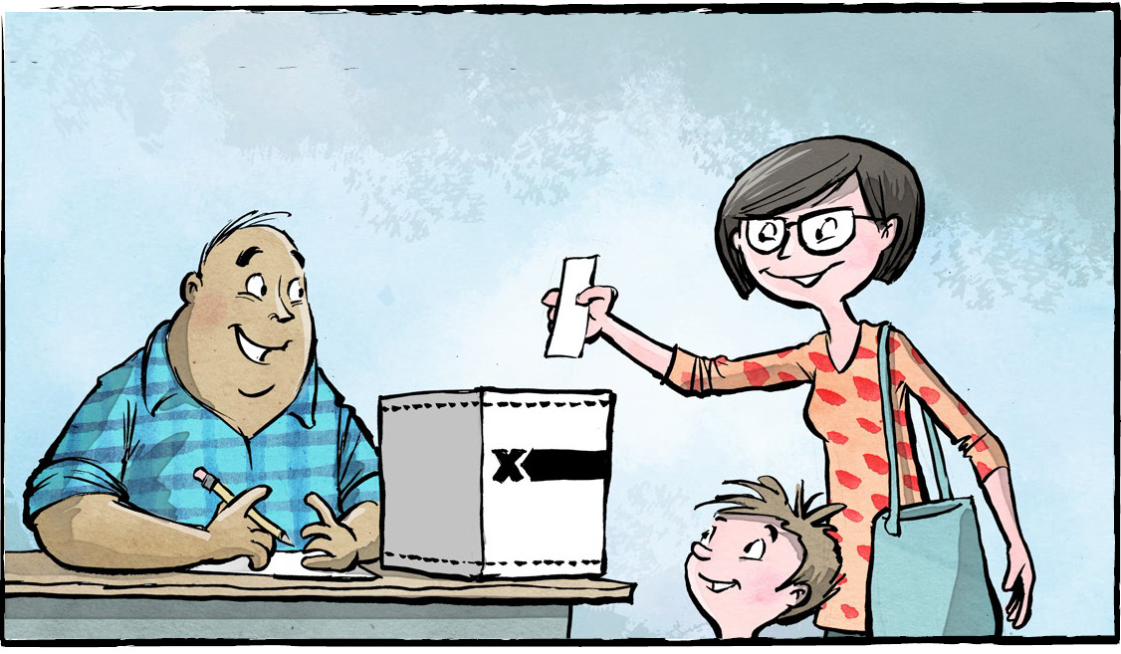

**Comprehension Check**

Write the letter of the *best* answer in the space beside each question.

**1. Who is the leader of the Liberal Party?**

a) Jagmeet Singh. b) Pierre Poilievre.  
 c) Mark Carney. d) Elizabeth May.

**2. What is a majority government?**

a) When a party wins 169 seats in an election.  
 b) When one party has more than half the seats in Parliament.  
 c) When a party drops below 12 seats.  
 d) When a party has at least 43.8 percent of the votes.

**3. What percentage of eligible voters voted in the 2025 federal election?**

a) Over 69.6 percent. b) Over 79.4 percent.  
 c) Over 68 percent. d) Less than 17 percent.

**4. What party lost official party status?**

a) The Green Party. b) The Bloc Québécois.  
 c) The Conservatives. d) The NDP.

**5. What are Mr. Carney's three core values for Canada?**

a) Humility, ambition, and unity.   
 b) Strength, resolve, and hard work.  
 c) Leadership, hope, and victory.  
 d) Kindness, perfection, and goodness.

**Language Focus**

A simple sentence expresses a complete idea. It always has at least one ***subject***and one***verb***.   
The ***subject*** is the noun or pronoun that carries out an action. A ***verb*** is a word (or words) that expresses an action.

For example: He (*subject*) voted (*verb*) in the election.

***Directions****:*  Circle the verbs and underline the subjects in these simple sentences.

**1.** On April 28, Canada held a federal election.

**2.** Canadians voted in the federal election.

**3.** The officials counted the votes carefully.

**4.** The Liberals won the election.

**5.** The NDP lost many seats.

**6**. Jagmeet Singh stepped down as leader of the NDP.

**7**. Mr. Carney promises to work hard.

**8.** He called for us to work together.

**9.** Candidates campaigned across the country.

**10**. Journalists reported the results.

**How many other simple sentences can you find in the article?**

From Hats to Helpers: The Story of the Beaver

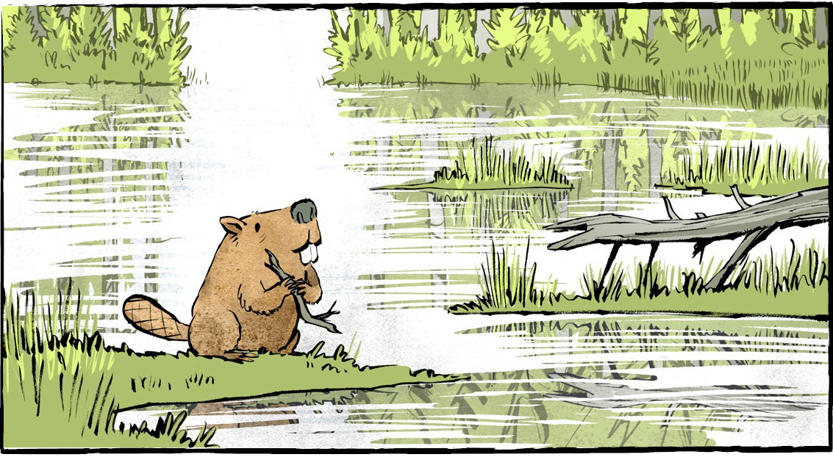

This animal has been on a Canadian coin since 1937. In 1851, it appeared on Canada’s first stamp. It played a key role in the fur trade. At one time, it was nearly extinct. Fifty years ago, it became a symbol of Canada. Can you name this animal?

If you said the beaver, you’re correct!

This hardworking animal is part of Canada’s history.

In the 1600s, beaver pelts were in demand in Europe. They were used to make fashionable hats.

The demand for beaver pelts brought Europeans to Canada. It sparked exploration and colonization. This eventually led to Canada becoming a country.

The beaver came to represent Canadian sovereignty. On March 24, 1975, it became an official symbol of Canada. But the beaver stands for much more.

**Wetland wisdom**

For the Anishinaabe people, the beaver symbolizes wisdom. They define wisdom as using your natural gifts to help others and the land.

Beavers help the land by building dams. The dams slow water and make wetlands. Wetlands help plants grow and make safe spaces for animals to live. Wetlands even fight climate change. They trap carbon (CO2) and stop it from going into the air. Each year, beaver wetlands hold as much carbon as 100,000 cars produce.

**Hairy helpers**

Beavers help in other ways, too. After a forest fire, it is the first animal to come back. Beavers rebuild the land so it's safe for other animals to return.

In the winter, many animals share the beaver’s dam. Turtles, frogs, and fish hide in the mud to stay warm. Muskrats may come inside too. They share the space, like roommates!

Beaver dams are very strong, like bridges. They can help other animals cross rivers and wetlands.

**The industrious beaver**

Beavers work hard. There is even an expression, “busy as a beaver.” That’s why many people say beavers symbolize industriousness. It takes a lot of hard work to shape your environment!

The fur trade nearly wiped out the beaver population. By the late 1800s, beavers were almost extinct. Fortunately, fashion changed. People did not want beaver hats anymore. Once hunting slowed down, beavers made a comeback. Today, the beaver is not even at risk. This is one reason why beavers are seen as symbols of resilience.

The beaver’s role in the fur trade makes it a   
symbol of Canada’s natural resources   
and history.

Beaver dams represent Canada’s natural beauty. They remind us to care for nature. We share this land with each other and with Canada’s wildlife. Like the beaver, we need to work hard and help others.

Do you think the beaver is a good symbol for Canada? What animal would you choose?

In Anishinaabemowin, the beaver is called Amik. In Cree, it is Amisk.

What else do you know about beavers?

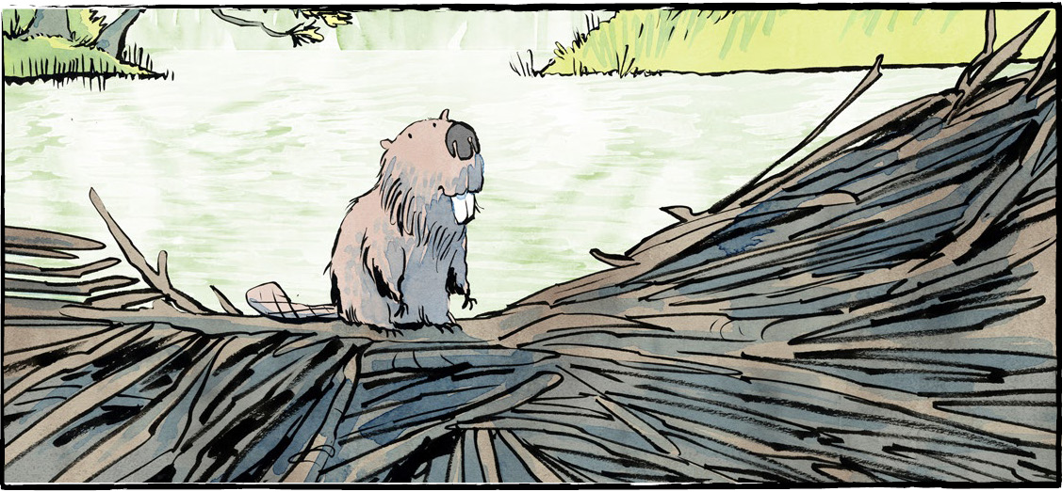

**Long before European settlers arrived in Canada, Indigenous Peoples used beaver fur to make clothing. The animal’s bones were used to make tools. It was also a valuable food source. A substance from its glands could even be used to catch other animals!**

**Comprehension Check**

Answer the questions below in complete sentences:

1. What does the beaver represent for the Anishinaabe people?

2. How are wetlands good for nature?

3. Which animals share a dam with beavers?

4. What saying do people use to describe someone who works hard?

5. What activity nearly wiped out the beaver population?

**Language Focus**

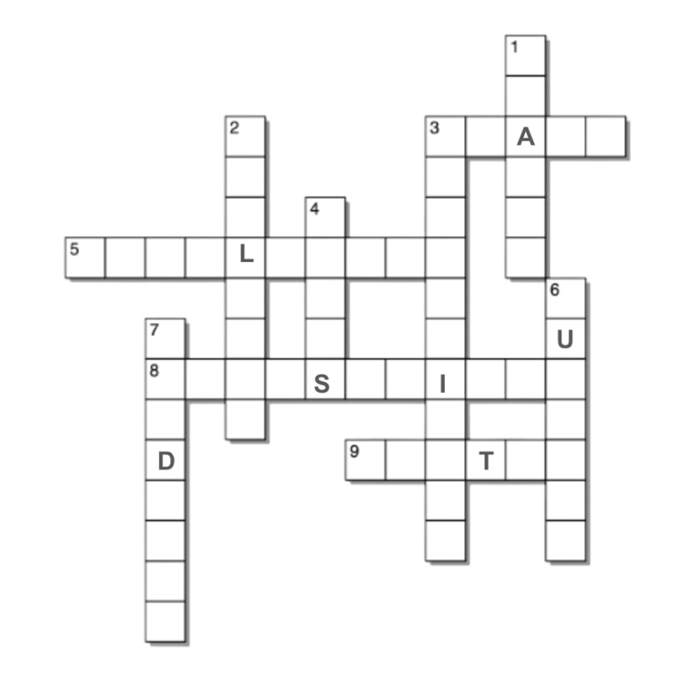

**ACROSS**

3. where the beaver appeared in 1851

5. able to recover quickly from stress

8. always busy

9. the season when animals hide in a  
dam to stay warm.

**DOWN**

1. an expression, “busy as a ”

2. areas that help plants grow and trap CO2

3. being free from outside control

4. beaver were used to make hats in Europe

6. a beaver’s possible roommate

7. animals and plants that live in nature

**Symbols of Canada**

**Comprehension Check**

Write the letter of the *best* answer in the space beside each question.

1. **A symbol . . .**

a) is very complicated b) stands for something else   
 c) is an animal d) stands alone

2. **Which three countries are represented in our coat of arms?**

a) France, the U.K., Quebec b) Canada, the U.S., France  
 c) the U.K., Canada, France d) the U.S., Quebec, the U.K.

3. **How many official symbols does Canada have?**

a) six b) nine  
 c) twelve d) one

4. **Which of the following is** *not* **an official Canadian symbol?**

a) the polar bear b) the Maple tree  
 c) the beaver d) the Canadian horse

5. **What are Canada's two official sports?**

a) baseball, lacrosse b) soccer, hockey  
 c) baseball, hockey d) none of the above

**What are the symbols for your province or territory?**

