Articles and Questions
Each free article of The Canadian Reader – Supplementary News includes:
1) a PDF file
and
2) a Word file
These files contain only the article and questions. They do not contain Answer Keys.
This Word file allows students to complete assignments using a computer either at school or at home. Teachers can assign all or parts of the file by email attachment or a school website. The Word file also allows teachers to:
• easily modify and format content including changing fonts and text sizes
• create a PDF document and use Adobe Reader's 'Read Out Loud Mode'
• save paper and copying costs and help protect the environment
• promote and encourage students’ computer skills

What Else Can You Do With The Word File?
#1) You can easily upload the file to Google Docs and share it with students or other teachers. See how here:
https://support.google.com/drive/answer/2424368?hl=en
#2) Translate the uploaded document into another language. (see Tools>Translate document). Google Docs will create a new copy of the original file but you will need to edit the document to suit your requirements. Google Docs can translate into over 100 languages including Spanish, Mandarin, German, etc. See how here:
https://support.google.com/docs/answer/187189?hl=en&co=GENIE.Platform=Desktop

The 2022 Terry Fox Run
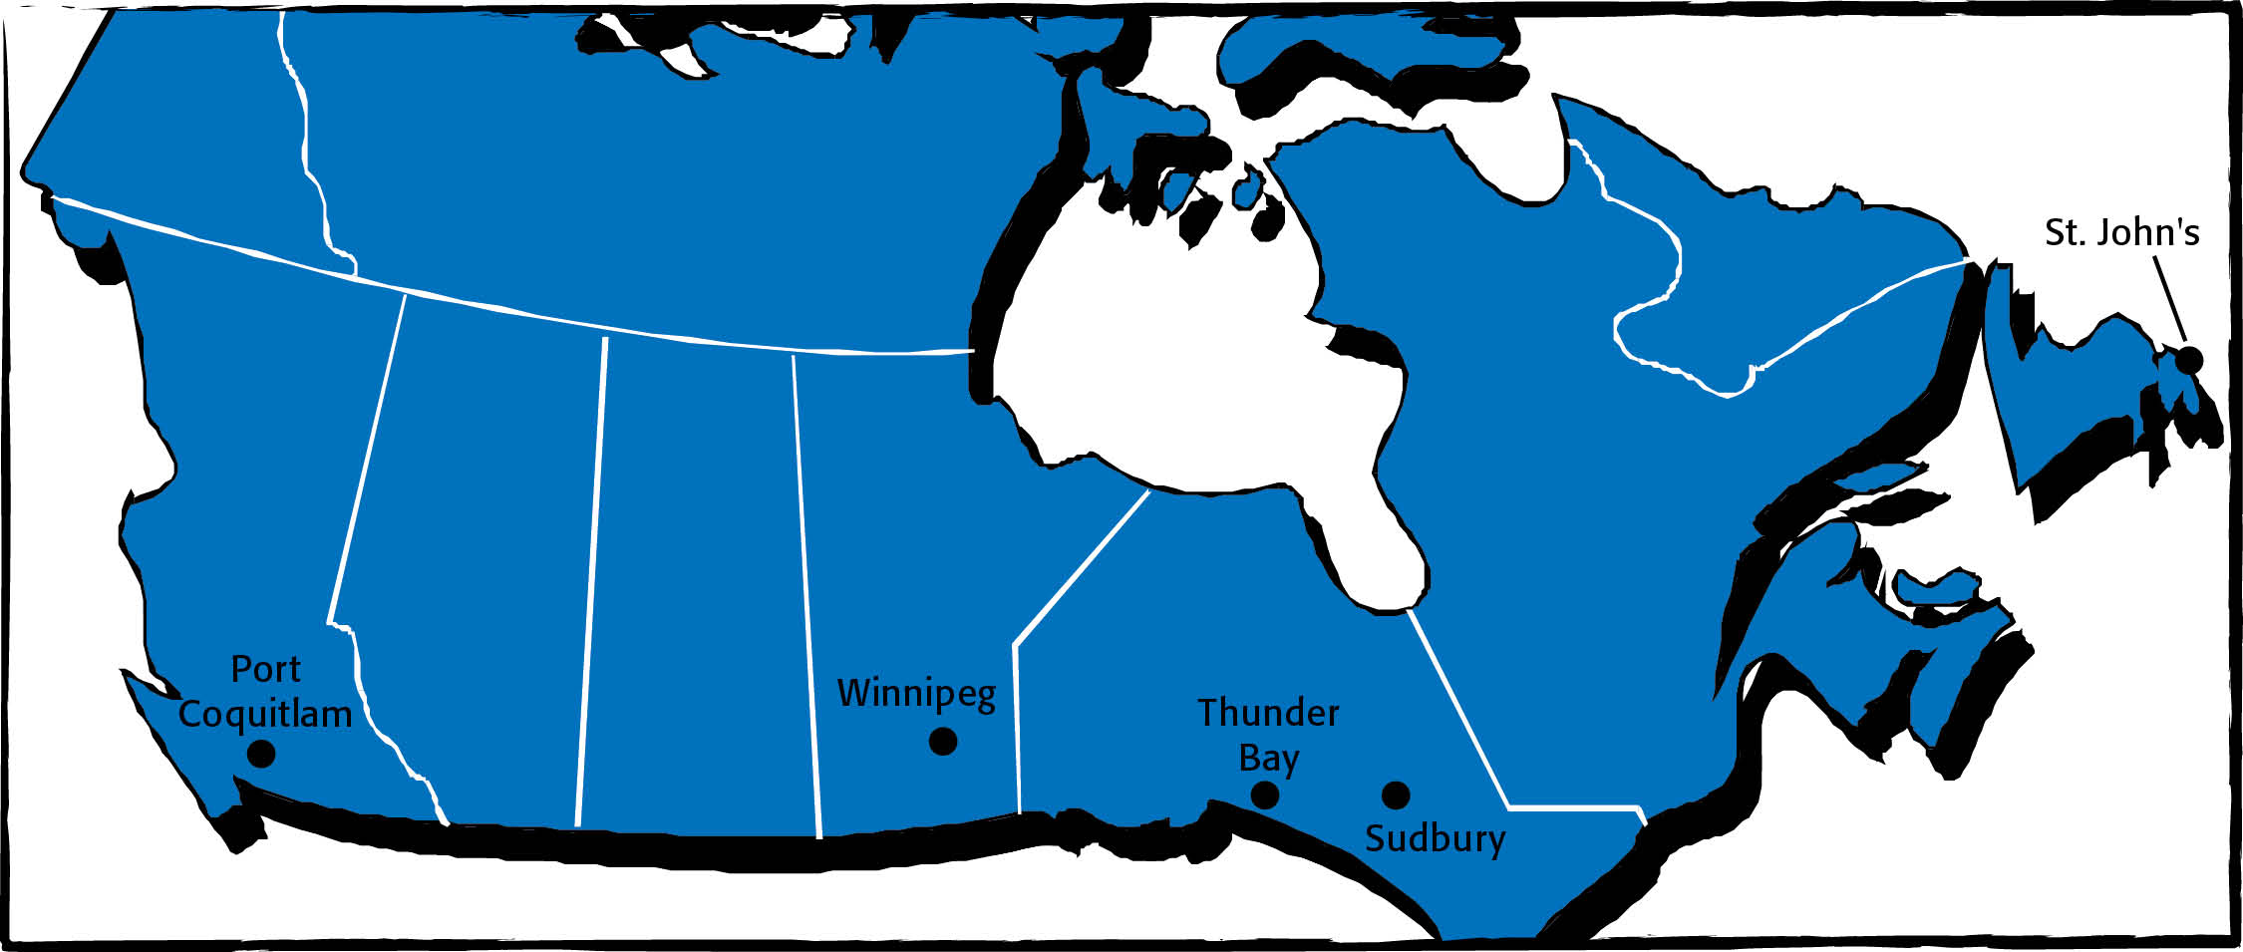
Remember to wear your gym shoes on September 23. Chances are, you’ll be going for a run or a walk on that day. So will everyone else in your school. You’ll be taking part in the Terry Fox Run.
This run takes place every September. It is held to raise money for cancer research. It also honours the memory of a very special man: Terry Fox.
Terry was born in Winnipeg, Manitoba, in 1958. When he was a child, his family moved to Port Coquitlam, B.C. That’s where he grew up.
As a boy, Terry loved sports, especially basketball. He wanted to be a gym teacher one day. But when he was just 18 years old, doctors found out that Terry had bone cancer. They had to amputate his leg above his knee.
Did Terry feel sorry for himself because he had an artificial leg? No! He felt very lucky. The cancer was gone. Now, he wanted to help others with this disease.
Terry had a plan. He was going to raise money for cancer research. His goal was to raise one dollar for every Canadian. There were 24 million people in our country at that time. He would raise the money by running across Canada.
Terry trained for over a year. Then, on April 12, 1980, he began his Marathon of Hope. He started off near St. John’s, Newfoundland. Every day, he ran about 42 kilometres. It wasn’t easy for Terry. But he was determined. He stuck to his plan.
Sudbury, Ontario was the halfway point in the Marathon of Hope. By the time Terry reached this city, his run had really taken off. He had raised $11.4 million. Large numbers of people were turning out to cheer him on.
Then, bad news: just outside of Thunder Bay, Terry began to feel sick. Doctors found that the cancer had spread to his lungs. He had to stop running. He had to return home for treatment.
Canadians were inspired by what Terry had done. They decided to carry on where Terry had been forced to leave off. Across the country, people continued to raise money in Terry’s name. By February 1981, over $24 million had been collected.
Terry was very happy. His goal had been reached. But sadly, on June 28, he died.
Three months later, on September 13, 1981, the first Terry Fox Run was held. Over 300,000 Canadians took part. This run raised another $3.5 million.
Since then, the Terry Fox Run has been held every year on the second Sunday after Labour Day. Since 2005, a Terry Fox School Run has also been held about two weeks after the main run. In all, more than $850 million has been raised to date in Terry’s name.

Amputate means to cut off a limb. Something that is artificial is made to take the place
of something natural.

Did you know…? In all, Terry ran 5,373 kilometres in 143 days during his Marathon of Hope.

As you see it, what is the importance of this story?
Why should we care about Terry and the Terry Fox run?

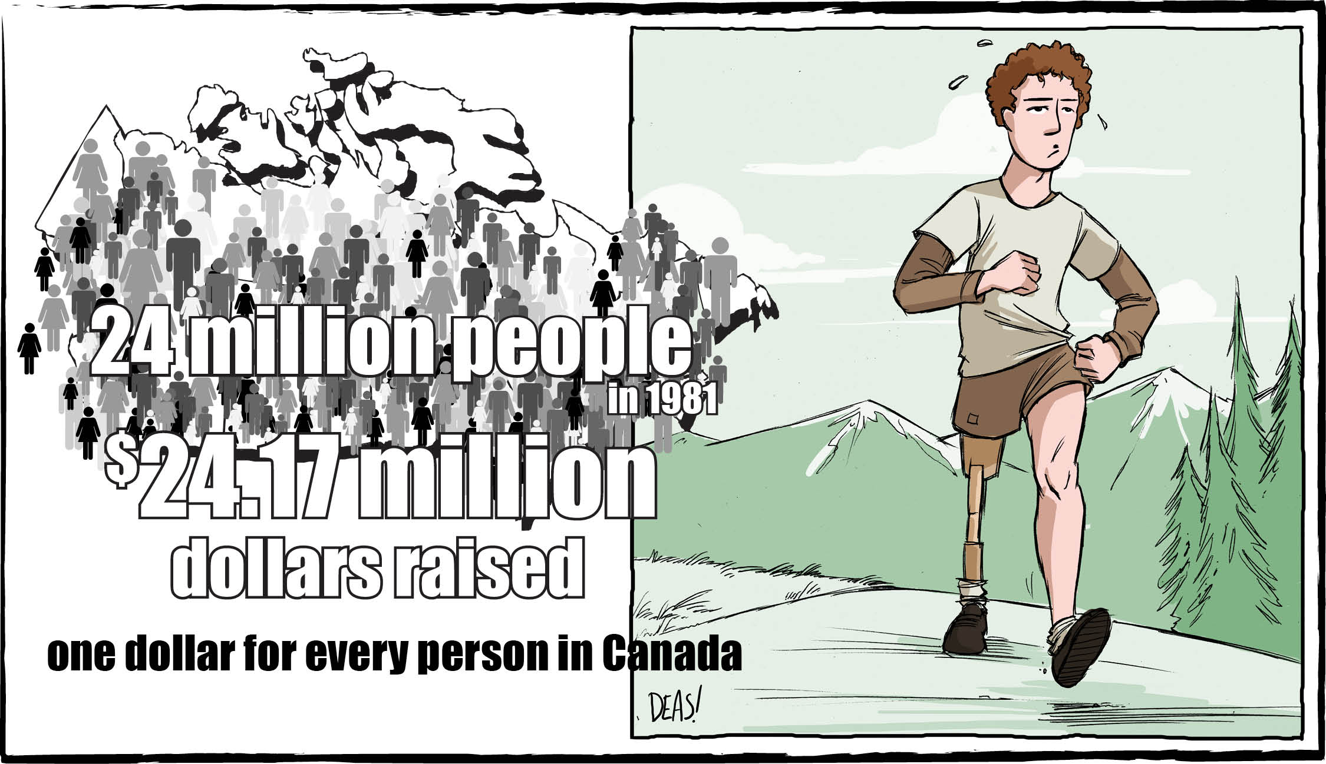

KWL Chart
What I  KNOW | What I  WANT TO KNOW | What I  LEARNED

Practice It!

Match the prefixes re- or un- to the root words in the word list to make new words.

re- | un-
rewind | unable

able
afraid
charge
copy
do
done
fair
fund
like
loved
move
pack
play
run
search
stuck
train
turn
wrap
wind

As you see it, how do adding the prefixes re- and un- change the meaning of words?

Answer It!

Write the letter of the best answer in the space beside each question.

1. During what month is the Terry Fox run held each year?
a) August b) September
c) October d) June
2. Where did Terry Fox begin his run to raise money for cancer?
a) St. John's, Newfoundland b) Thunder Bay, Ontario
c) Victoria, B.C. d) Montreal, Quebec
3. What was Terry Fox 's fundraising run called?
a) the Golden Marathon b) the Marathon of Hope
c) Run for the Cure d) Cops for Cancer
4. How far did Terry Fox run every day?
a) about 42 kilometres b) exactly 4.2 kilometres
c) 10 kilometres d) 1 kilometre
5. How much money has been raised over the years in Terry Fox's name?
a) exactly $11.4 million b) about $73 million
c) about $350 million d) more than $850 million

What is a hero?
As you see it, for what reasons could Terry Fox be considered a hero? Explain.

