Articles and Questions

Each **free article** of ***The Canadian Reader*** includes:   
  
1) a PDF file

*and*

2) a Word file

These files contain **only** the article and questions. They do **not** contain Answer Keys.

This **Word** file allows students to complete assignments using a computer either at school or at home. Teachers can assign all or parts of the file by email attachment or a school website. The **Word** file also allows teachers to:

• easily modify and format content including changing *fonts* and text sizes

• create a PDF document and use Adobe Reader's 'Read Out Loud Mode'

• save paper and copying costs and help protect the environment

• promote and encourage students’ computer skills

What Else Can You Do With The Word File?

#1) You can easily upload the file to Google Docs and share it with students or other teachers. **See how here:**

<https://support.google.com/drive/answer/2424368?hl=en>

#2) Translate the uploaded document into another language. (see **Tools>Translate document**).Google Docs will create a new copy of the original file but you will need to edit the document to suit your requirements. Google Docs can translate into over 100 languages including Spanish, Mandarin, German, etc. **See how here:**

<https://support.google.com/docs/answer/187189?hl=en&co=GENIE.Platform=Desktop>

The Farm of the Future?

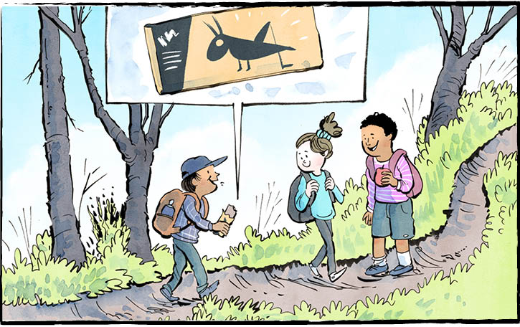

A new farm just opened for business. It’s not the sort of farm you might imagine. This farm raises crickets! It uses artificial intelligence to help look after them.

Does that sound like a farm from a science fiction movie? It’s very real.

It’s actually a cricket-processing facility in London, Ontario. It belongs to a company called Aspire Food Group. It may be the biggest cricket-processing facility in the world.

Just like animals at a farm, crickets are born and raised there. They are also harvested there.

This all happens with the help of a system that uses **artificial intelligence**. Basically, the system looks after the crickets and learns what keeps them healthy. The system checks the light levels and the water in the air. It tracks the temperature. And it listens to the sounds the crickets make. The more it learns, the better it gets at keeping the rooms just right.

**Why raise crickets?**

As it turns out, crickets offer many benefits. Every part of the cricket can be eaten. Eating crickets gives your body important vitamins and minerals. They’re also a good source of protein.

Aspire Food Group suggests comparing the same amount of powdered cricket and of meat. The cricket will have almost as much protein as the meat. It will also have less fat and fewer calories.

Eating crickets can also be good for the planet. Crickets need less food and water than other protein sources, like cows. Crickets don’t create as much greenhouse gas as cows do. This is good because greenhouse gas contributes to climate change. Maybe best of all, crickets are small. They don’t need as much land to live on. So, by raising crickets, we can produce more food with less stress on the planet.

**Tasty options**

People have been eating insects for thousands of years. Today, insects are a common food around the world. Even here in North America, crickets are becoming a more popular snack. Movie star Angelina Jolie says her kids eat them like Doritos! Some people say they have a sort of nutty flavour.

Crickets can be fried in oil. They are also often roasted and eaten whole.

Roasted crickets can be ground into a powder, too. The powder is used as an ingredient in cooking. It can also go into drinks like smoothies. There is even cricket flour, for baking. Imagine cricket cookies!

Most of the product from the new cricket farm will be used to make pet food. It turns out crickets are good for dogs and cats, too! But there is a growing market for crickets for restaurants and supermarkets.

Would you eat a cricket?

**Artificial intelligence** refers to the capability of a machine to imitate intelligent human behaviour.

As you see it, what is the biggest benefit of eating crickets?

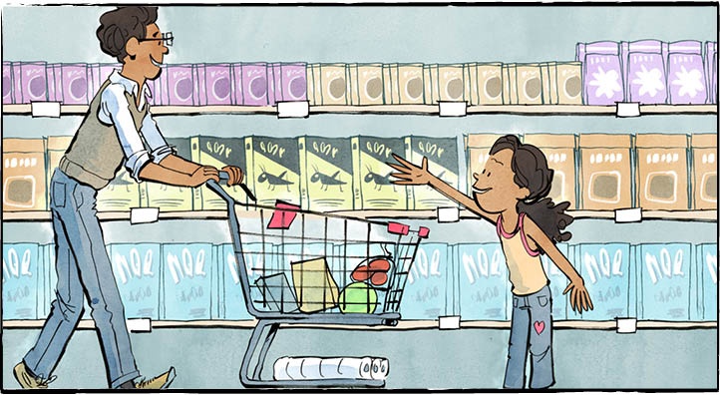

**Aspire Food Group's facility is expected to house four billion crickets and produce 13 million kilograms of the insect each year.**

**Comprehension Check**

Answer the questions below in complete sentences:

1. Who or what looks after the crickets?

2. What does eating crickets give your body?

3. List three reasons why eating crickets can be good for the planet.

4. To what flavour do people compare crickets?

5. Where will most of the product from the new cricket farm go?

**Language Focus**

Write each word from the list in the correct tag.



**What other words from the article can you add to each tag?**