Articles and Questions
Each free article of What in the World? includes:
1) a PDF file
and
2) a Word file
These files contain only the article and questions. They do not contain Answer Keys.
This Word file allows students to complete assignments using a computer either at school or at home. Teachers can assign all or parts of the file by email attachment or a school website. The Word file also allows teachers to:
• easily modify and format content including changing fonts and text sizes
• create a PDF document and use Adobe Reader's 'Read Out Loud Mode'
• save paper and copying costs and help protect the environment
• promote and encourage students’ computer skills

What Else Can You Do With The Word File?
#1) You can easily upload the file to Google Docs and share it with students or other teachers. See how here:
https://support.google.com/drive/answer/2424368?hl=en
#2) Translate the uploaded document into another language. (see Tools>Translate document). Google Docs will create a new copy of the original file but you will need to edit the document to suit your requirements. Google Docs can translate into over 100 languages including Spanish, Mandarin, German, etc. See how here:
https://support.google.com/docs/answer/187189?hl=en&co=GENIE.Platform=Desktop

A League of Their Own
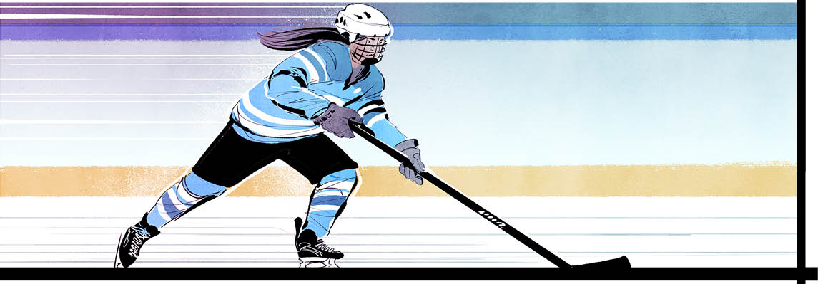

Enthusiasm is mounting as players, coaches, and prospects pack up for November training camps. They’re readying for the January 2024 launch of the Professional Women’s Hockey League (PWHL).
The league will have six teams. Three franchises will operate in Montreal, Toronto, and Ottawa. The other three will be U.S.-based. They are Boston, Minnesota, and New York.
The first season will have 24 games. Seasons will expand to 32 games in the future. Players will strut their stuff on everything from NHL-sized rinks to ice in minor hockey venues.
“This is an extraordinary opportunity to advance women’s sports,” said tennis legend and women’s sports advocate Billie Jean King, who backed the league’s creation. She will help run it and says it will inspire a new generation of players.
Little time to prep
The PWHL is working overtime to get the show on the road by January.
The to-do list is a long one. Team names and logos need to be chosen. Transportation must be organized. Schedules have to be set. Equipment must be readied.
“The thought of standing up one team in an existing league in six months is kind of nuts,” said Stan Kasten, of the PWHL’s advisory board. “Here we are trying to stand up six teams in a new league. Yet, we’re going to do it. I’ve never felt more confident… that we are going to have our first games in January and our first season in 2024.”
Fighting for fairness
The formation of the league ends a period of instability in the pro women’s hockey circuit. It’s also a testament to the determination and grit of women who stood their ground.
The PWHL can trace its roots back to the Premier Hockey Federation (PHF). It founded the National Women’s Hockey League (NWHL) in 2015.
The NWHL was the first female hockey league to pay players. It lured many stars away from the Canadian Women’s Hockey League (CWHL), which didn’t offer salaries. The CWHL folded in 2019 after 12 seasons.
Then, in its second season, the NWHL asked players to take a salary cut. That angered many of the women in the four-team organization. As a result, 200 top female players declared that they wouldn’t take part in any North American league until they were properly paid. They also demanded necessary resources. They created a union, the Professional Women’s Hockey Players’ Association (PWHPA), to help push for these changes.
The tactics worked. Last June, new owners bought the PHF and its asset, the NWHL. The players’ union hammered out an agreement with them. It guarantees minimum salaries of $35,000 (US). Players also receive travel expenses, health insurance, pregnancy and parental leave, and other benefits.
The fun begins
With these issues settled under one new league, the future appears bright for professional women’s hockey.
The PWHL draft got underway in September and free-agent picks were announced. Fans eagerly followed the action.
Some big names? On the Canadian side, Ottawa asked Becca Gilmore to attend camp. Ms. Gilmore won a world championship with the U.S. national team last spring. And she scored six points in 11 games for the Boston Pride.
Ottawa also invited Mikyla
Grant-Mentis. Ms. Grant-Mentis earned 21 points in 24 games with the Buffalo Beauts. As for goaltending, Toronto drafted Team Canada gold medallist Kristen Campbell.
Time to get to work
PWHL training camps start in mid-November after the Canadian and U.S. national teams compete in a Rivalry Series. It's one of the best match‑ups in sport. USA Hockey and Hockey Canada started the Rivalry Series in 2018.
Training will likely run for several weeks to bring the 180 players attending up to speed. Many haven’t played since the spring. It will be the first time the new coaches will get to see their developing teams in action.
The best from afar
The new sports organization is not only drawing North America’s best female players. It’s also attracting premier talent from Europe and Asia.
Dominika Lásková, a Czech national drafted by Montreal, is among them. She hopes to be a model for others in her country.
“I think it’s great for the little girls back home to see that there is a possibility for them to play [alongside] the best players in the world,” she said.
American forward Hilary Knight says she expects these players to change the game.
“I’m giddy about it just from a fan’s perspective," she says. "We see it on the men’s side. [But] you’ve never seen the hockey minds meet from different countries on the women’s side.”
Seeing the action
For now, PWHL games will just be streamed, but the league is hoping for regular TV coverage eventually. Teams will play some games outside their home cities, in NHL arenas in neutral territory or in cities without NHL franchises. Wherever they'll play, fans can’t wait to see them.
“This is another step forward for the women who play professional hockey and the girls who dream of it every day,” said league rep Johanna Boynton.

Did you know?
The PWHL unveiled its logo on October 24. It features crossed hockey sticks that help form a “W” against a purple background.

advocate: a person who supports or speaks in favour of somebody or of a public plan or action
draft: a system for sports teams to choose new players
union: an organization of workers formed to protect the rights and interests of its members
professional: describing the situation when someone is paid to participate in a sport or activity
testament: something that serves as a sign or evidence of a specified fact, event, or quality

Comprehension Questions

1. What is the PWHL?

2. How old is this organization? How many teams belong to this league?

3. Where will the Canadian teams be based? Where will the American teams play?

4. How many games will each team play during the first season?

5. When will PWHL training camps begin? How many players are expected to attend?

6. When will the regular season start?

7. How will home games be different from most other sports?

8. List at least two things that still need to happen before the season starts

9. What makes the PWHL different from earlier women's hockey leagues? Explain.

Questions For Further Thought

1. Canadian Olympic hockey champion Brianne Jenner is quoted as saying: “When I was growing up in the game, I dreamed of playing for Team Canada, because that’s what I saw on TV. I didn’t think something like this was possible.”
As you see it, how might this pro women’s hockey league affect interest in hockey? Support your response with examples.

2. John Tavares, captain of the Toronto Maple Leafs, had this to say about the PWHL: "You want to see them flourish. The international game, it's been tremendously successful, a lot of fun to watch, and they're great athletes. They play a great game that we all love. They do a great job at it and deserve the opportunity to have their own league and develop a history of pedigree — a legacy — just like we have as men."
What is your understanding of this statement? As you see it, how might John Tavares' comments be received by PWHL players? Explain.

Questions For Online Exploration
Note: The links below are listed at www.lesplan.com/links for easy access.

1. Visit the PWHL's official website: https://www.thepwhl.com/

2. Learn more details about the PWHL:
https://www.cbc.ca/news/canada/pwhl-women-hockey-guide-1.6965776
http://www.cbc.ca/player/play/2259609667987 [2:06]
What does the league mean for women’s hockey?

3. Learn more about the PWHL’s inaugural draft and the first players to be signed:
https://www.cbc.ca/sports/3-stories-inaugural-pwhl-draft-donkin-sept18-1.6970865
https://www.cbc.ca/sports/hockey/pwhl-draft-explainer-sept15-1.6967144
Which players were signed first? Why do you think they were chosen before the others?

4. Jayna Hefford, senior vice-president of PWHL operations and member of the Hockey Hall of Fame, explains what the PWHL means for hockey and women’s sports in general:
https://www.yout-ube.com/watch?v=3YSQpqjI9RU [6:24]
What is the importance of this league?

5. Who are some of the players to watch in the PWHL?
https://www.cbc.ca/sports/hockey/pwhl-draft-10-intriguing-players-1.6965619

6. Visit the Hockey Hall of Fame website to learn about the pioneers of women's hockey:
https://www.hhof.com/hockeypedia/womenshockey.html
What questions do you have?

Putting It All Together

A. Write the letter that corresponds to the best answer on the line beside each question:
______ 1. How many teams belong to the PWHL?
a) 4 b) 6
c) 12 d) 14
______ 2. Canadian PWHL teams will play in:
a) Quebec City, New York, Montreal b) Vancouver, Toronto, Ottawa
c) Ottawa, Toronto, Montreal d) Toronto, Calgary, Ottawa
______ 3. The minimum yearly salary for each PWHL player will be:
a) $35,000 (US) b) $75,000 (US)
c) $225,000 (US) d) $1,000,000 (US)
B. Mark the statements T (True) or F (False). If a statement is True, write one important fact to support it on the line below. If a statement is False, write the words that make it true on the line below.
______ 4. True or False? The PWHL is the first women’s hockey league that will pay its players.
______ 5. True or False? PWHL teams do not yet have team names and logos.
______ 6. True or False? PWHL teams will play all away games in the other team's home arena.
C. Fill in the blanks to complete each sentence.
7. PWHL teams will play _______________________ games during the first season.
8. The PWHPA is a _____________________created to represent and negotiate for PWHL players.
9. The PWHL _______________________ consists of crossed hockey sticks that form a "W".
D. Respond to the following question in paragraph form. (Use a separate sheet of paper if necessary.)
10. What impact do you suppose the PWHL might have on women's hockey? On women's sports in general? Give reasons to support your response.

