Articles and Questions
Each free article of The Canadian Reader includes:
1) a PDF file
and
2) a Word file
These files contain only the article and questions. They do not contain Answer Keys.
This Word file allows students to complete assignments using a computer either at school or at home. Teachers can assign all or parts of the file by email attachment or a school website. The Word file also allows teachers to:
• easily modify and format content including changing fonts and text sizes
• create a PDF document and use Adobe Reader's 'Read Out Loud Mode'
• save paper and copying costs and help protect the environment
• promote and encourage students’ computer skills

What Else Can You Do With The Word File?
#1) You can easily upload the file to Google Docs and share it with students or other teachers. See how here:
https://support.google.com/drive/answer/2424368?hl=en
#2) Translate the uploaded document into another language. (see Tools>Translate document). Google Docs will create a new copy of the original file but you will need to edit the document to suit your requirements. Google Docs can translate into over 100 languages including Spanish, Mandarin, German, etc. See how here:
https://support.google.com/docs/answer/187189?hl=en&co=GENIE.Platform=Desktop

Saving the Ojibwe Horse
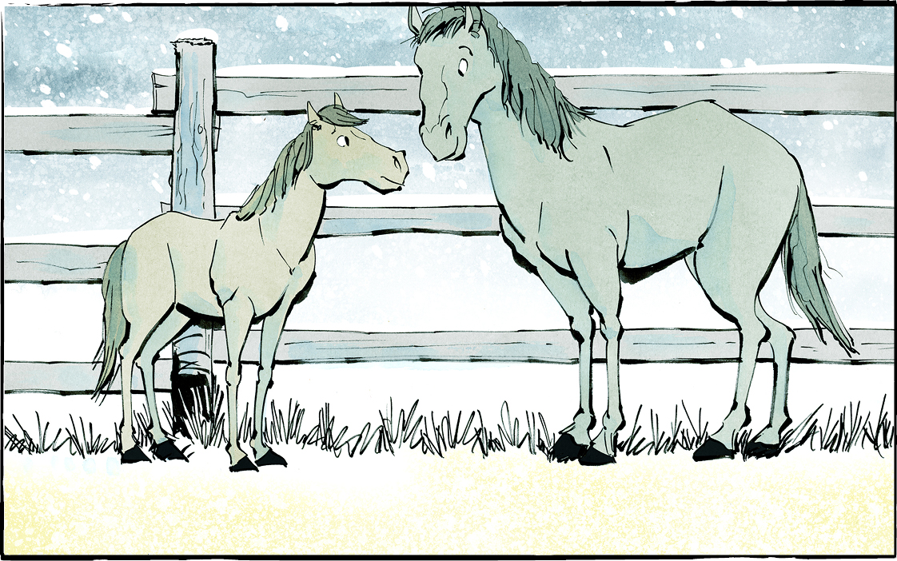

A special breed of horse is making a comeback in Canada. It’s called the Ojibwe Horse, or the Lac La Croix Indigenous Pony.
This horse was bred by Ojibwe people. It is thought of as a spirit animal.
We almost lost these beautiful horses forever.
Built for the north
These horses were built for the northern woods. They are small—less than 1.5 metres at the shoulders. Their small size helps them push through the brush.
Their hard hoofs are perfect for rocky ground. In winter they grow shaggy coats. Special nose flaps protect them from cold air in winter.
Their ears are small and hairy, and their manes are thick. This helps protect them from the cold, and also from bugs!

Seen as a nuisance
In the early 1900s, thousands of Ojibwe Horses roamed free.
Settlers saw them as a nuisance. They got angry when the wild horses grazed on their fields. So, they hunted the horses. Sometimes they were used for dog food. Their numbers shrank.
Fifty years ago, Darcy Whitecrow was a child. He lived in Seine River First Nation, in northwestern Ontario. He remembers the horses roaming free like deer.
But by 1977, only four mares were left. They were the last of their kind.
A daring rescue
The mares lived on reserve at Lac La Croix First Nation. The Canadian government said they were a health risk. It wanted them killed.
Five men rescued the mares. There were no roads they could use, so they waited for winter. When Lac La Croix was frozen, they rounded up the mares and loaded them onto a trailer. Then they drove over the ice.
It was a dangerous, difficult journey. But at the end, the mares found safety on a farm in Minnesota.
Growing numbers
There were no male Ojibwe Horses left. To keep the breed from dying out, the mares were bred with a mustang. Over time, the population grew.
Eventually, some of the horses were brought back to Canada. Thanks to Darcy Whitecrow and his wife, Dr. Kim Campbell, they even came back to Seine River First Nation!
Saving the Ojibwe horse
Mr. Whitecrow and Dr. Campbell run Grey Raven Ranch. They offer programs for Indigenous youth.
The young people spend time in nature and work with the horses. They learn about their culture. They are part of something important, too. By helping the Ojibwe Horse, they are saving the breed their ancestors developed.
The horses are still endangered. Today, there are fewer than 200 in the world. At Grey Raven Ranch and in other places, people are working to keep these special horses alive.
Thanks to them, the Ojibwe Horse has a future.

What questions would you like to ask Mr. Whitecrow or Dr. Campbell?

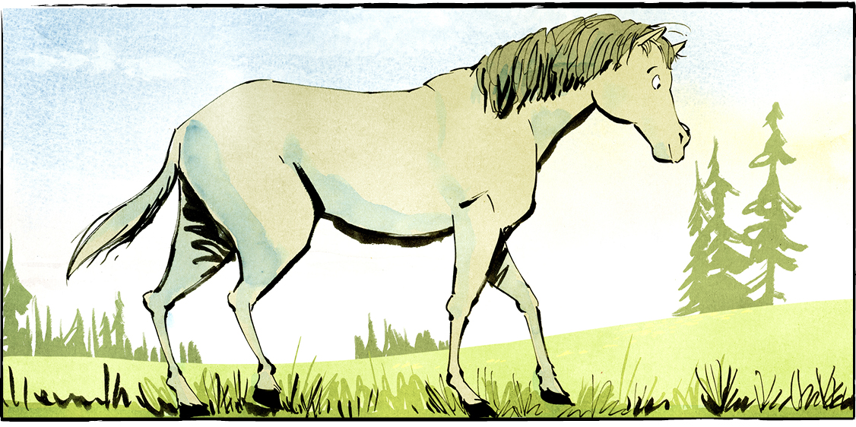
Comprehension Check
Answer the questions below in complete sentences:

1. What is another name for the Ojibwe Horse?

2. What happened to the horses when spring came?

3. What protects the horses from cold air in winter?

4. Who brought Ojibwe Horses back to Seine River First Nation?

5. The horses are still endangered. How many Ojibwe Horses are there in the world today?

Language Focus
An antonym is a word that means the opposite of another word.
Examples: good/bad, true/false, high/low
Directions: Complete the table below.

Word | Antonym
lost
beautiful
pull
wild
cold
small
thick
Now choose two pairs of words from the table above. Use each of the words in a sentence that shows its meaning.
1.

2.

3.

4.

